|  |  |
| --- | --- |
|  | **MINISTRY OF EDUCATION AND TRAINING** |

**FPT UNIVERSITY**

**Capstone Project Document**

|  |
| --- |
| **English For Kid** |

|  |  |
| --- | --- |
| **E4K Team** | |
| **Group members** | Truong Minh Tien - SE61076  Kieu Minh Tam - SE02832  Dang Van Tuan - SE02433  Nguyen Hai Long - 01417 |
| **Supervisor** | Mr. Phan Duy Hung |
| **Capstone project code** | E4K |

Contents

Contents 1

I. Introduction 3

1. Document Introduction 3

1.1 Purpose 3

1.2 Acronyms and Definitions 3

2. Abstract 4

3. Existing systems 4

3.1 Kids ABC letters 4

3.2 E-kidsongs 5

4. Idea 6

5. Proposal for the new system 6

5.1 Comparison between Android OS and iOS 6

5.2 E4K project proposal 7

II. Software Project Management Plan 16

1. Project organization 17

1.1 Software Process Model 17

1.2 Roles and Responsibilities 18

1.3 Tools and Techniques 22

1.4 Development environment 23

2. Project management plan 23

2.1 Tasks 23

2.2 Task Sheet: Assignments and Timetable 25

2.3 Communication Plan 26

2.4 Coding Convention 26

III Software Requirement Specification 26

1. Purpose 26

2. Functional Requirements 27

2.1 Use Case Diagram 27

2.2 Use Cases 29

3. Non-functional requirements 45

3.1 Availability 45

3.2 Security 46

3.3 Maintainability 46

3.4 Performance 46

3.5 Usability 46

3.6 Compatibility 46

4. Common requirements 46

5. Success Criteria 46

IV. User Interface Design 47

1. Main Screen 47

2. Listening game 48

2.1 Listening game menu screen 48

2.2 New words game menu screen 49

2.3 Multi choice game menu screen 51

3. Speaking game 54

3.1 Speaking game screen 54

4. Writing game 55

4.1 Writing menu game screen 55

4.2 Queue game screen 57

4.3 Queue game result 58

4.4 Arrange game screen 60

4.5 Arrange game result 62

4.6 Missing word game screen 63

4.7 Missing word game result 64

5. Vocabulary game 65

5.1 Vocabulary game screen 65

5.2 Vocabulary game result 67

V. Algorithm design 68

1. Game play 68

1.1 Listening game 68

1.2 Speaking game 71

1.3 Writing game 72

1.4 Vocabulary game 76

2. Non function Algorithm 79

2.1 Multi-Language Support 79

2.2 Multi-Screen size Support 80

VI. System Implementation & Test 81

1. Introduction 81

3.1 Overview 81

3.2 Test Approach 82

2. Test Plan 84

2.1 Features to be tested 84

2.2 Features not to be tested 85

2.3 Testing Tools and Environment 85

3. Test cases 86

3.1 Module 1 87

3.2 Module 2 89

3.3 Module 3 91

3.4 Module 4 92

3.5 Module 5 94

3.6 Module 6 98

3.7 Module 7 99

3.8 Module 8 101

3.9 Module 9 105

VII Application Installation 109

1. Set up environments 109

2. Set up app 112

VIII. User Guide 118

1. Introduction 118

2. Guidelines play game 118

2.1 Play listening new words game 118

2.2 Play listening multi choice game 119

2.3 Play speaking game 121

2.4 Play writing queue game 122

2.5 Play Writing missing word game 125

2.6 Play Writing arrange word game 127

2.7 Play vocabulary game 129

IX Reference for project 132

# I. Introduction

## Document Introduction

### Purpose

This document is created to provide overview of project. It will include the overview of some existing system, the ideal of our project, a brief description about our expected system.

### Acronyms and Definitions

|  |  |
| --- | --- |
| Acronym & Abbreviation | Definition |
| * E4K | * English for kid |

Table 1: Definitions and Acronyms

## Abstract

In today’s global world, the importance of English can’t be denied and ignored since English is the most common language spoken everywhere. With the help of developing technology, English has been playing a major role in many sectors including medicine, engineering, and education. Because of the important of English, Many parents want to help their child or children to learn English but are not sure what they can do to help. Almost people let’s their child learning English at school but have low effectiveness because they study not only English but also another subjects at school. Others people choose foreign language Center but they have to pay a high price for this. About 5 years ago with the development of the Internet, people can learn English by a computer connect with the Internet. But it is rather expensive, and inconvenient because of big size. Besides, smart phone now become the popular device. So people can take advantage of technology to learn English more convenient. With simple app, kid can learn English every time and everywhere. No way to learning English better than playing some funny game with colorful. From this problems, our application will tends to

* Help consumers saving their money on foreign language Center.
* Child can study English by themself via interest games.
* It causes excitement for children, make them feel interesting with learning English.
* It is a useful method of intellectual entertainment, help kids not only feel relaxed but also have new knowledge about English.

## Existing systems

### Kids ABC letters

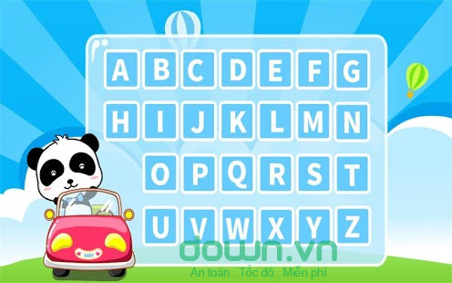

Kids ABC Letters app for android is the English alphabet learning for young children.

**Advantages:**

* Very fun.
* This app invites preschoolers will hear and learn ABC alphabet in ways that can make them spellbound.
* Children will learn to spell letters and practicing drawing them
* Children will identify and search alphabetic letters in a passage that scene.

**Disadvantages:**

* Does not teach children about the phonetic like the alphabet used to

### E-kidsongs



Learn vocabulary through English songs

**Advantages:**

* Very fun.
* Fast receptive.
* Free and offline

**Disadvantages:**

* This app is just a list of video.

## Idea

E4K is an app help kids learning English. Our app will include all function listening, reading, writing. By tap on the screen, kids can learn English with fun and interest. We toward on give kid environment to play and learn English more attractive and interesting.

## Proposal for the new system

From the given idea, the project is mainly target to the suppliers of groceries or suppliers with existing delivery system. As for the consumers, we want even people with average income able to use their phones to shop. Choosing the appropriate smartphones to work with will bring us a start with a larger pool of users which can bring back more possibility of success.

Vietnam Smartphone market now has plenty type of phones with different operating system. According to sale data, smartphones come with these two operating systems are the new trend:

* iOS: exclusive for Apple products
* Android OS: has a wide range of phone currently using from various phone manufacturers (Samsung, HTC, Sony Ericsson...)

*This does not mean we only develop for one chosen OS. Application for the remaining OS will be developed in the future as we get users' feedback for the demo application.*

### Comparison between Android OS and iOS

#### Market share

According to data provided by IDC (International Data Corporation), in Q3 2011, Android has a market share of 67% of total smart phone in use in Vietnam, while iOS only has 39,3%[1]. This can be easily explained because Android supports a wide range of phones, from the really cheap ones from China to the as expensive as iPhone of Apple.

Application download from appstore is also to Android's favor. Statistic from one of the largest application providers of Vietnam – appstore.vn – shows that Android application providing service after only 6 months in use grew to have more than 120,000 users. Compare to the 978,000 of iOS, it is only one ninth, but also according to their static, the growth of users of Android is more than 40% a month, which will surpass iOS in the middle of 2012[2].

From these points, we can see that Android is fast growing and becoming more and more popular with Vietnamese users.

#### Development

Android is developer friendly since it uses Java and XML which are more popular than Objective-C of Apple. Android can also be debugged and tested easily while Apple requires you to provide an account for testing applications.

Android support easier web communicate because it is Java based.

Android market is free to up, which mean developers can have their applications up in the market fast, opposite to Apple's app store: applications will be checked to ensure there is no harm to the users.

#### Conclusion

For the current scope of the capstone project, we choose Android for the following reason:

* Android provides a better environment for the current scope of this project: fast development environment, based on Java so there are many open source available for reference.
* From the point of user, Android is now widely used and at the top place of the smart phone market. In Vietnam, although Android is quite new, but recent trend show that its market share is growing fast. Android phones are also have a wide range of price, so many users can afford buying one for our application, while iPhone are quite expensive and not everyone can buy. This means developing on Android will get back many benefits like having a large pool of users, which result in more feedback data.

### E4K project proposal

In this new system, we will inherit the good points of the existing application and overcome their limitations.

#### System based on

Our product based on the “Next stop 1” book



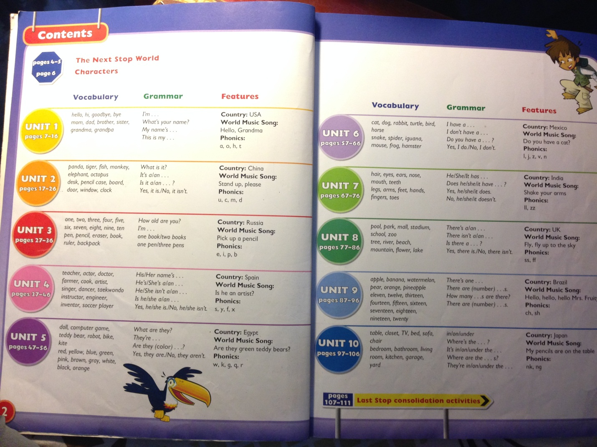

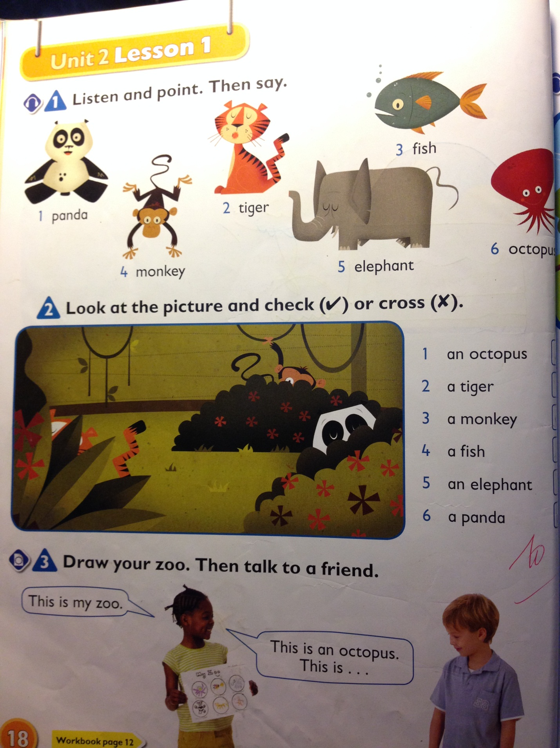

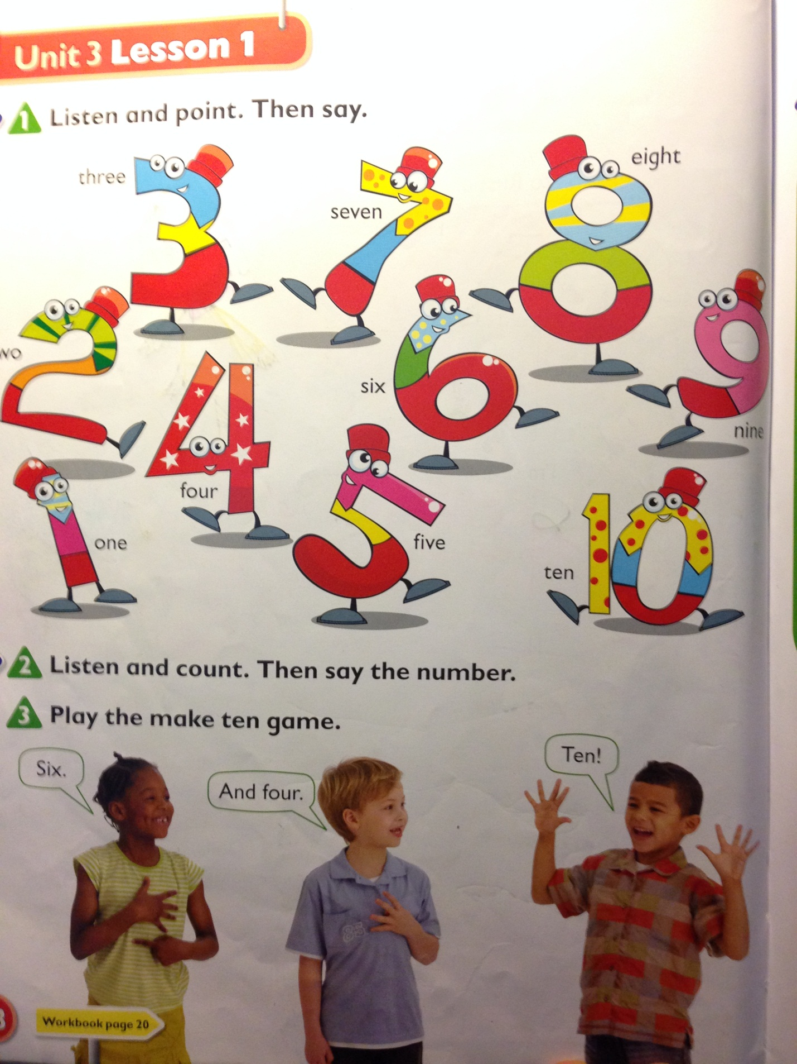

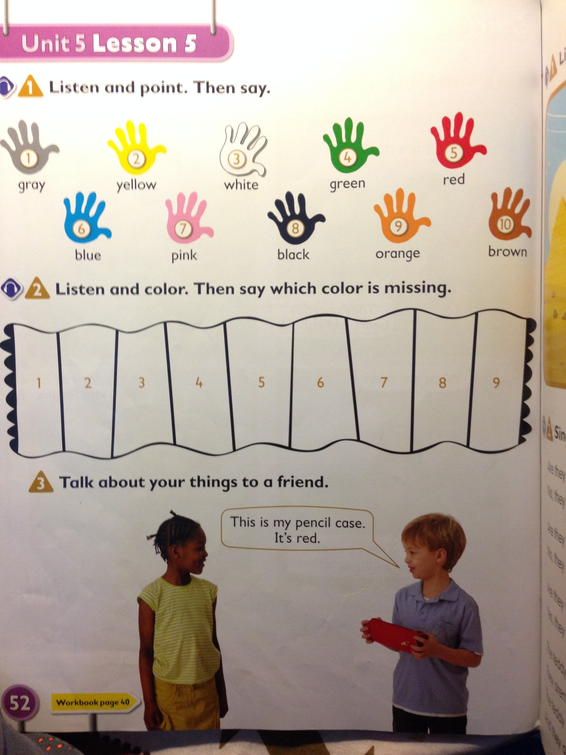

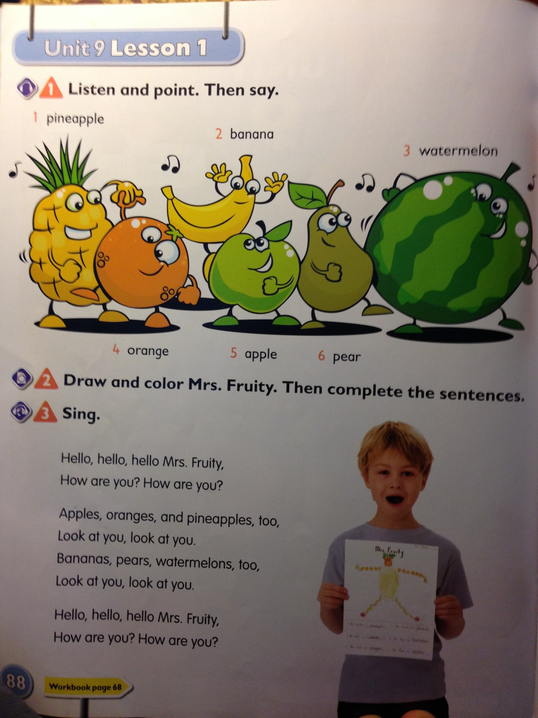

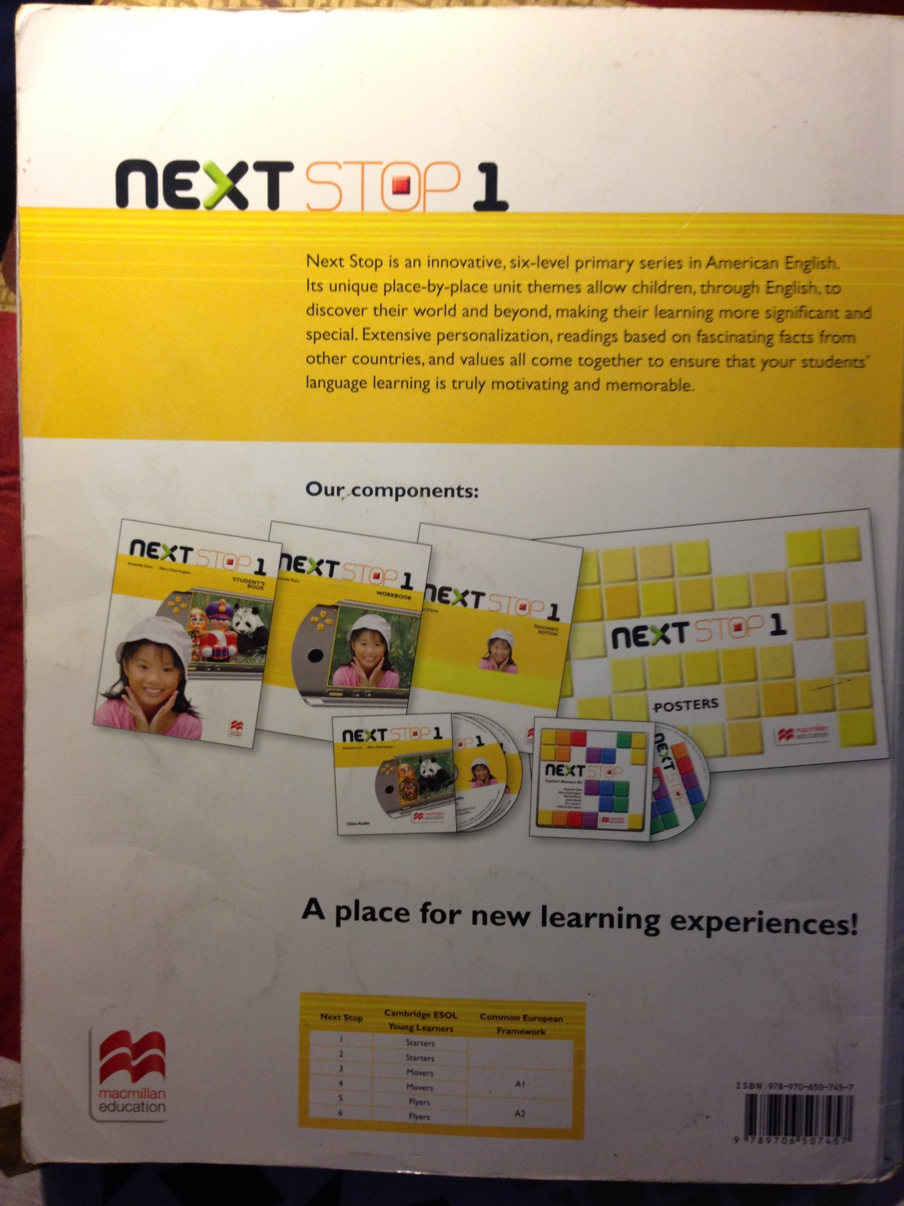

#### Overview

The application meets the needs all the skills of reading, speaking, listening, writing, vocabulary. So we have mini game for each skill separately

1. **Listening**

* Multi choice game
* There are 5 topic: animals, alphabet, fruit, objects, color. (maybe more)
* Each topic has 10 questions
* The each question to 4 image (random in the database about 50 times), after hearing from the corresponding new image selected (which allows playback buttons)
* Your selection will be audible to indicate right or wrong then switched to next question
* Done 10 questions will sum up the score.
* Learn new words through hearing
* There are 5 topic: animals, alphabet, fruit, objects, color. (maybe more)
* Choose one topic will be the image of that subject appeared in turn, click on the emitted sound and text, swipe to reveal another image.

1. **Speaking**

* Standard Pronunciation
* Show out and pronounced the word correctly.
* App will display the text corresponding to the user's pronunciation to users compare and know they mispronounce or exactly.
* If the correct pronunciation automatically switches to the next word.
* If mispronounce out the text of mispronounce it, and users can pronounce it correctly, or press next to move to the next word.

1. **Writing**

* Games queue
* Screen that shows any one word.
* Players scored one word that begins with the last letter of the word given. (Eg given from TABLE -> players fill EMPTY is correct).
* If the player is playing audio properly filled correctly and additional point, load the next and to play.
* If players answer incorrectly or out of time, the sound wrong and show current points.
* Character is missing
* For images and the characters of the image meaning but will be missing few characters (For example the images of a table and the table below form stating TA_LE. Requires completion players missing characters.
* If you filled out correctly pronounce properly and then moved to another image and add point, if selected incorrectly, the sound wrong and summary points out.

* Number the word in order
* For image and the character meaning of that image but random order (Examples for table image and the image below is a table that shows A B T L E. From these suggestions, but the wrong order and miss 1 character which requires players to fill right from TABLE).

1. **Vocabulary**

* Multi choice
* There are four topic: objects in the house, animals, fruit, color. (maybe more)
* Each topic has 10 questions.
* Show the first image and four answer A B C D is the vocabulary related to that picture.
* Choose the correct answer is vocabulary
* Your selection will be audible to indicate right or wrong, then switched to next question
* Done 10 question will sum up score.

#### New feature

Kid have to learn all the skill.

They learn standard pronunciation, listen native Enghlish .

Mini game will stimulate thinking ability and memory of children.

*The capstone project may not have all the features of the completed system as listed above due to the lack of time and resources. For more information please read 1.4.2 – Boundaries of the system*

#### Limitations

In the scope of the capstone project

* Support only Android (Another OS will be support in the future)
* Response to young children or the beginners get acquainted with the English

#### Potential business risks

* Database is big, difficult to prepare amounts of data
* Lacks of children participate in using the final application. This may be because of the thought of afraid to change.

# II. Software Project Management Plan

## Project organization

### Software Process Model

The project is planned to be completed within 2.5 months with the team of 4 people. So each person must handle one or more function of the product, self-analyzing, define tasks and be able to work cross-functional.

In a short time, we are building and improving the product step by step. Hence we can track the defects at early stages. This avoids the downward flow of the defects. So we used iterative and incremental development in the process model used for developing this project

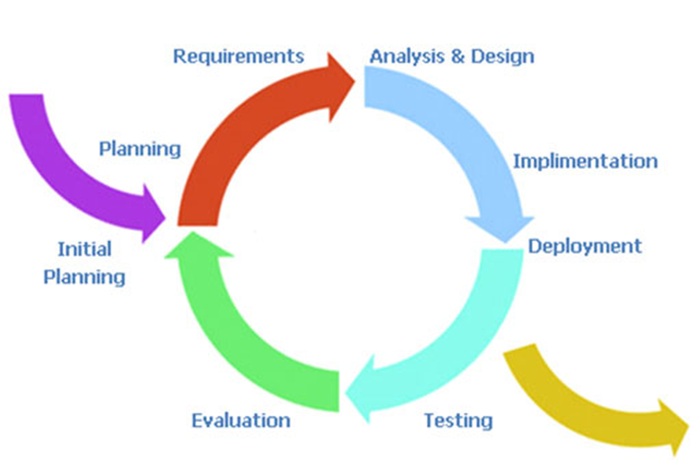

Figure 1: Iterative Model - Software Development Model

### Roles and Responsibilities

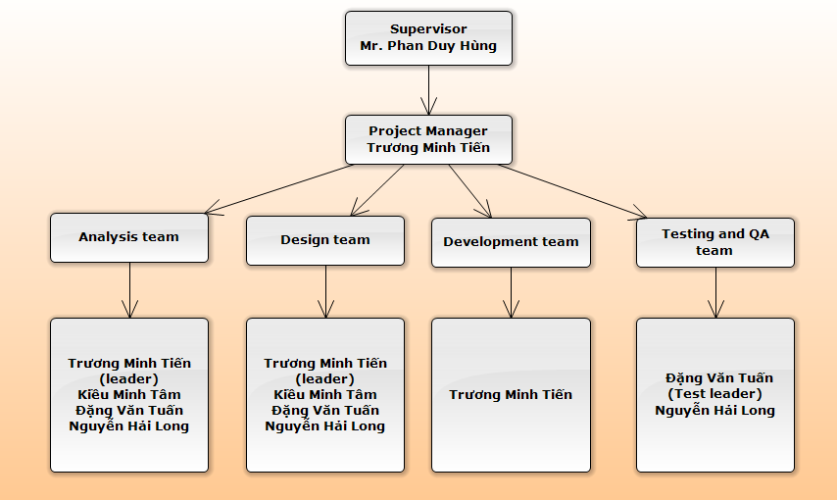

**Here is the table that lists all roles and corresponding responsibilities in this project:**

|  |  |
| --- | --- |
| **Role** | **Responsibilities** |
| Project manager | * Managing and leading the project team. * Responsible for driving the overall planning, management and completion of information technology projects and technical implementations. * Leads projects by ensuring scheduling, delegating and monitoring project tasks, and reviewing project deliverables. * Responsible for all project communication, including project status reporting and organizing project meetings and documents discussion and action items. * Ensures all project documentation is complete, accurate, and current. * Contact and work with the PS by reporting updates regarding the team’s progress status, obstacles, and concerns as well as eliciting advice. |
| Project Technical Leader | * Conduct research and recommend the most appropriate technologies, tools and methodologies that should be used for this project. * Co-ordinate research efforts related to the project. * Communicate information gathered or discovered from research to the team via email or during meetings. * Support team members using the information discovered from research during the course of this project. |
| Quality assurance | * Control quality and managerial processes. * Analyze and report test results. Evaluate test results as soon as possible after execution. Compare all test results with expected results and note that all defects are documented, regardless of how minor they appear or whether they will be corrected. * Email weekly summaries of processes not being followed. If a process does not end in resolution, QA must raise the issues in the next team meeting. * Write meeting minutes. |
| Developer | * Delegate coding tasks. * Code, execute unit test and assure coding quality. * Provide coding assistance for other members. * Main developer must write the team’s coding guidelines and standards. |
| Risk manager | * Define risks as well as solutions at first stage of starting the project and manage, mitigate and monitor risks during this project’s lifetime. * Conduct risk treatment strategies when risks occur in the attempt to reduce the impact on this project. |
| Tester | * Design and document test cases, execute test cases, record test case results, document and track defects, and perform test coverage analysis. * In this capstone project, Testers will do Function test and System test:   - The test designer creates test cases that test at the level of distinct business events or functional process.  - The test designer creates test cases that test at the level of the system (Stress, Performance, Security, Recovery, etc.) or complete end-to-end business threads. |
| Configuration manager | * Responsible for providing the overall CM infrastructure and environment to the product development team. * Ensure that directories and files in the SVN repository have correct structure and permissions and train team members to use SVN via email or during work sessions, meetings. * Perform baseline procedures when requested by the PM and monitor the team’s adherence to formal change procedures on baseline documents. * Perform daily and weekly backups of the team’s directory. |
| Document Maintainer | * Responsible for writing documents (gathering information, writing reports and project documentation). Has a responsibility for preparing a document for review, making review changes, updating the document version number. |

In this project, we assign tasks as follows:

|  |  |  |  |
| --- | --- | --- | --- |
| **No** | **Person** | **Skill: Rate(max = 5)** | **Role** |
| 1 | Truong Minh Tien | Managing Skill: 4  Technical Knowledge: 4  Coding java Android app: 5  QA & Test:2 | Project Manager  Risk Manager  Project Technical Leader  Developer |
| 2 | Kieu Minh Tam | Managing Skill: 4  Technical Knowledge: 4  Coding Java Android: 3  QA & Test:3 | Configuration Manager    Document Maintainer |
| 3 | Dang Van Tuan | Managing Skill: 3  Technical Knowledge: 3  Coding Java Android: 3  QA & Test:5 | Document Maintainer  Quality Assurance  Tester |
| 4 | Nguyen Hai Long | Managing Skill: 3  Technical Knowledge: 3  Coding Java Android: 3  QA & Test:5 | Document Maintainer  Quality Assurance  Tester |

* + General Tasks:
* Provide assistance to each member.
* Team member has responsible for writing some components which he (she) has done in the report and must complete assigned tasks on time.
* Maintain contact with the PM, TL and other to discuss the project’s progress, express issues and concerns for resolution.
* Identify risks and communicate them with the risk manager and the team.

### Tools and Techniques

**E4K project uses the following tools and techniques:**

1. Tools for coding:

* Eclipse with Android SDK
* Text document

1. Tools for documenting and merging codes, creating plan, updating status:

* Tortoise Git
* Microsoft Office 2010
* Microsoft Project 2010
* Software Ideas Modeler

1. Device for testing

* Asus zenfone 5 (Android 4.4)
* Asus zenfone 5 (Android 5.0)
* Sony M2
* Galaxy tab 3

### Development environment

1. Coding software will be installed and run on:

* Windows 7
* Windows XP

1. Development, demo and testing environment:

* Android 4.4 kitkat
* Android 5.0

1. API sever:

* Google speech recognize API

1. Platform for coding program:

* Java SDK 1.6

1. Software for coding:

* Text document
* Eclipse with Android SDK

1. Hardware for development:

* Laptop Dell with Intel core i5 2.0, 8GB DDR3, 512GB HDD, Monitor with resolution 1366x768
* Asus zenfone 5

## Project management plan

### Tasks

|  |  |  |  |  |  |
| --- | --- | --- | --- | --- | --- |
| **Tasks** | **Description** | **Deliverables** | **Resource needed** | **Dependencies** | **Risks** |
| Initial phase | Focus on studying and research information related to project objective, find existing solutions | ● Identify business objective, project objective   Learn about current systems: weak points, strong points   Find useful algorithms, libraries that are comfortable with project objective   Finish report No.1 | Document on Internet | NA | So many solutions for each part of our project. We must find what are the most solutions for our project |
| Project plan | Make clearly responsibility of each team member. Besides, we collection information to finish report No.2 | ● Collect requirements   Define scope   Create WBS(work breakdown structure)   Define activities   Estimate activities resource and durations   Develop schedule   Estimate cost, budget |  | Finish Initial phase | ● Lack of resource and document about the algorithms we use   Lack of information to choose which kind of equipment which is comfortable with programming |
| SRS | we work together to give out detail requirement of the system | ● A software requirement specification document:   External Interface requirements   System features   Software system attributes   Entity relationship diagram or data structures | NA | Finish Project plan phase | NA |
| Design System | Basing on SRS, we will create detail design for our system. | SDD document:   System architectural design   Component diagram   Detailed description of components   Sequence diagram   User Interface design | SRS document | Finish SRS phase | ● Lack of time |
| Implementation Testing | Developing system basing on  SDD document. Basing on SDD Design, SRS, we give out testing opinion and create test cases. | ● Release E4K project version 1.0 or beta version After finishing this phase, we can release a complete system and testing document such as:   Test Plan   Test cases   Checklists | SDD, SRS, URS  E4K project version 1.0 | Finish SDD phase  Finish implementation phase |  |
| Release project | Present our product with supervisors and create a guideline document. | ● PMS Project last version, document, slides presentation…   Final version of system and relative documents | ● E4K Project last version, document, slides presentation… | Finish testing phase | NA |

### Task Sheet: Assignments and Timetable

#### Work Breakdown Structure and Estimation

Refers to [E4K] ProjectManagement.mpp

#### Meeting schedule

| Communication Type | Method / Tool | Date | Information | Participants / Responsible |
| --- | --- | --- | --- | --- |
| Project Task Tracking | | | | |
| Daily Meeting | Face to Face, Skype | Daily(10 pm everyday) | Checking tasks progress | Project Team Members |
| Project Meeting | | | | |
| Kick-off Meeting | Face to face | 7-September-15 | Project introduction; Project plan; Estimate scope; | Supervisor, PM, Project Team Members |
| Project Progress Review Meetings | Face to face | Weekly (Saturday) | Communicate project status  Communicate and resolve any open issue, risks, and changes  Discuss any suggested improvement | PM, Project Team Members |
| Milestone Meetings | Face to face | Deliver report to supervisor | Project objective review, review report with supervisor | Supervisor ,PM, Project Team Members |
| Project Post-mortem Meeting | Face to face | Termination stage | Wrap-up  Evaluate project performance; Team performance; share experiences | Supervisor, PM, Project Team Members |

### Communication Plan

#### Team project communication

* Planning Phase: Team meeting daily at 10 p.m. everyday. Face to face meeting is the most effective way for team member to understand and clarify detailed requirement. Output of each meeting is a meeting minute to keep up important information.
* Implement Phase: All members implement all task that PM and leader assigned. At 10 p.m. every day, team meeting daily and report to the whole team following template below

#### Communication with supervisor

* Meets the supervisor at 8:30 a.m. Tuesday every week to get advices for issues, guide for writing document, correcting report and plan for the next week.
* When having troubles in project, project manager collects ideas from members and send email or have a meeting with supervisor to get instructions or advices.
* By the report, supervisor will tracking the progress of project

### Coding Convention

**Refer to:**

* AndroidCodingConventions.pdf
* Codeconventions-150003.pdf

# III Software Requirement Specification

## Purpose

This chapter outlines functional, non-functional, API and formulas requirements of our system. It also provides some format constraints in common requirements and project success criteria.

All member will word (design, code and test) based on the information provided in this chapter.

## Functional Requirements

### Use Case Diagram

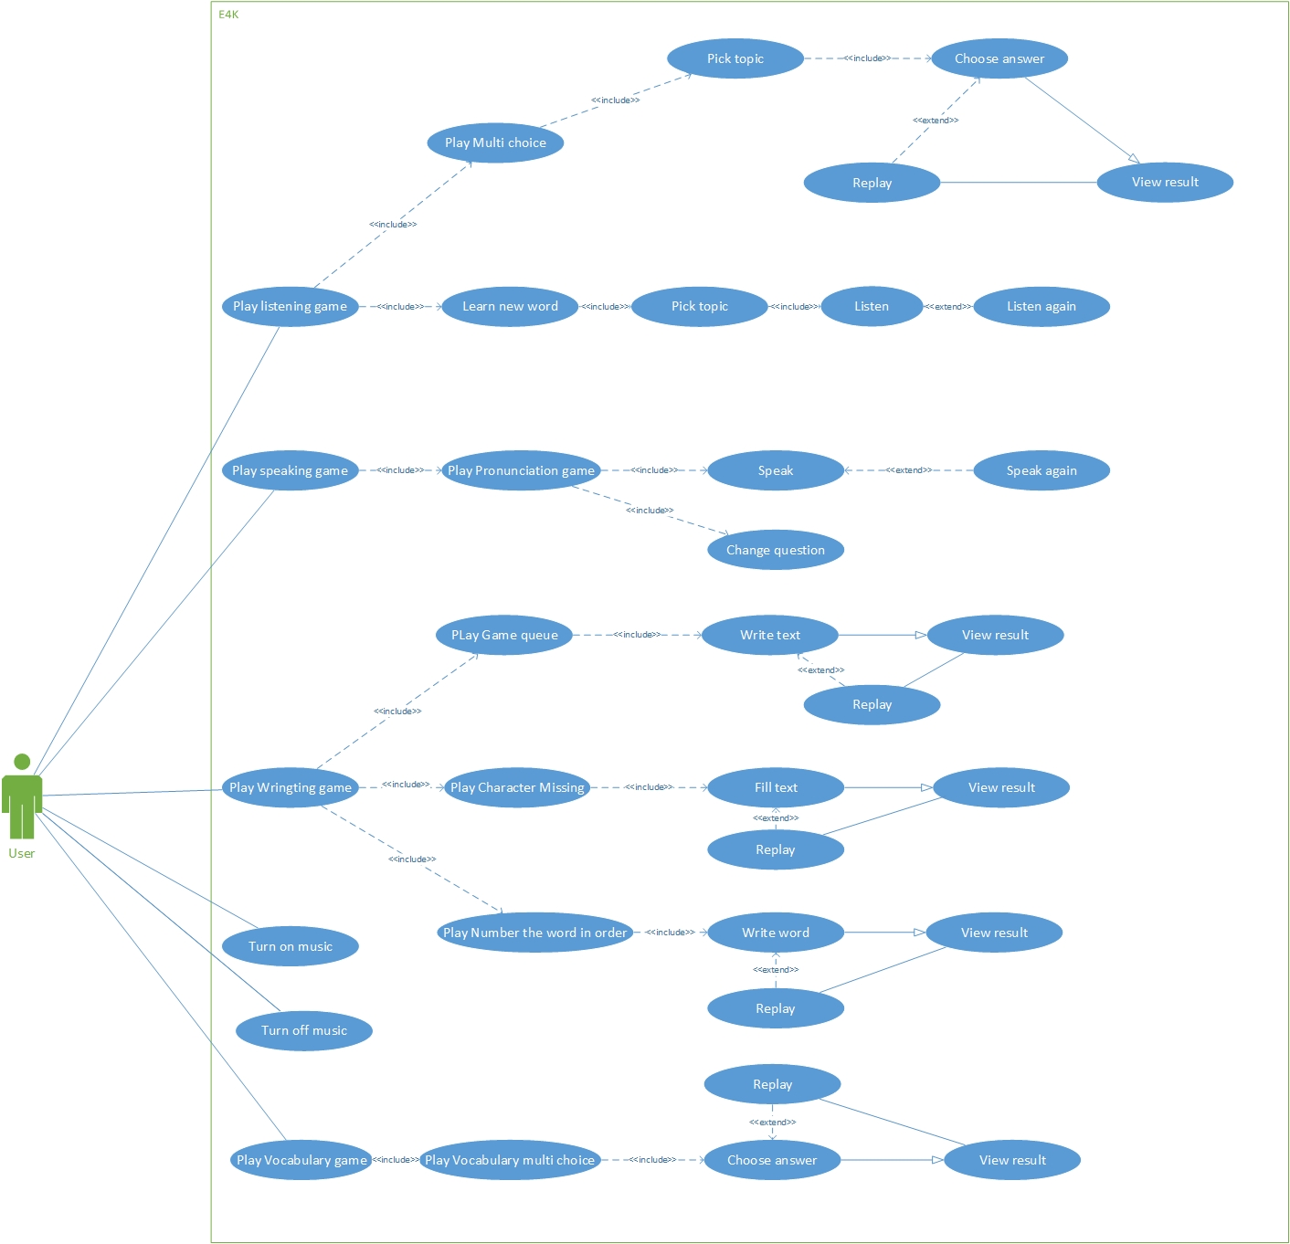

Figure 3‑1 Use case diagram

|  |  |  |
| --- | --- | --- |
| No. | Use-case Name | Summary |
| UC001 | Pick game | Allows users pick kind of game |
| UC002 | Pick topic | Allows users pick a topic |
| UC003 | Choose answer | Allows users choose an answer |
| UC004 | View result | Allows users view result |
| UC005 | Replay | Allows users replay game |
| UC006 | Listen | Allows users listen new words |
| UC007 | Listen again | Allows users listen new word again |
| UC008 | Speak | Allows users speak |
| UC009 | Speak again | Allows users speak again |
| UC010 | Change question | Allows users change question |
| UC011 | Write text | Allows users write text |
| UC012 | Fill text | Allows users to fill character missing |
| UC013 | Write word | Allows users write word |
| UC014 | Turn on music | Allows user turn on music |
| UC015 | Turn off music | Allows users turn of music |

### Use Cases

#### Choose answer

|  |  |  |  |
| --- | --- | --- | --- |
| **USE CASE 1 SPECIFICATION** | | | |
| **Use-case No.** | UC001 | **Use-case Version** | 1.1 |
| **Use-case Name** | Pick game | | |
| **Author** | TuanDV | | |
| **Date** | 21/10/2015 | **Priority** | High |
| **Actor**:   * Users.   **Summary**:   * This use case allows users to choose game to play.   **Goal**:   * Choose a game.   **Triggers:**   * Users tap on one menu game and choose game.   **Preconditions**:   * Show menu game.   **Post Conditions:**   * Have music background.   **Main Success Scenario:**   |  |  |  | | --- | --- | --- | | No | Actor | Action | | 1 | Users | Users see menu bar and choose game | | 2 | System | Enter the game | | 3 | System | Show menu in minigame |   **Alternative Scenario:**   * None   **Exceptions:**   * N/A   **Relationships:**   * None   **Business Rules:**   * N/A | | | |

#### Pick topic

|  |  |  |  |
| --- | --- | --- | --- |
| **USE CASE 2 SPECIFICATION** | | | |
| **Use-case No.** | UC002 | **Use-case Version** | 1.1 |
| **Use-case Name** | Pick topic | | |
| **Author** | TuanDV | | |
| **Date** | 21/10/2015 | **Priority** | High |
| **Actor**:   * Users.   **Summary**:   * In some game users need to pick a topic to play. This use case allows users pick topic.   **Goal**:   * Pick a topic.   **Triggers:**   * Users tap on one of six topics given by the system.   **Preconditions**:   * Five topics are shown up successfully.   **Post Conditions:**   * Pick a topic successfully. * Redirect to question screen.   **Main Success Scenario:**   |  |  |  | | --- | --- | --- | | No | Actor | Action | | 1 | Users | Users tap on one of six topics given by the system | | 2 | System | Display question screen |   **Alternative Scenario:**   * None   **Exceptions:**   * N/A   **Relationships:**   * None   **Business Rules:**   * N/A | | | |

#### Choose answer

|  |  |  |  |
| --- | --- | --- | --- |
| **USE CASE 3 SPECIFICATION** | | | |
| **Use-case No.** | UC003 | **Use-case Version** | 1.0 |
| **Use-case Name** | Choose answer | | |
| **Author** | LongNH | | |
| **Date** | 21/09/2015 | **Priority** | High |
| **Actor**:   * Users.   **Summary**:   * This use case allows users to choose an answer.   **Goal**:   * Choose an answer.   **Triggers:**   * Users tap on one of four options given by the system.   **Preconditions**:   * Four options are shown up successfully.   **Post Conditions:**   * There is one alert sound given by the system. * Redirect to next question screen.   **Main Success Scenario:**   |  |  |  | | --- | --- | --- | | No | Actor | Action | | 1 | Users | Users click on one of four options | | 2 | System | Plays an alert sound | | 3 | System | Shows next question |   **Alternative Scenario:**   * None   **Exceptions:**   * N/A   **Relationships:**   * None   **Business Rules:**   * N/A | | | |

#### View result

|  |  |  |  |
| --- | --- | --- | --- |
| **USE CASE 4 SPECIFICATION** | | | |
| **Use-case No.** | UC004 | **Use-case Version** | 1.1 |
| **Use-case Name** | View result | | |
| **Author** | TuanDV | | |
| **Date** | 21/10/2015 | **Priority** | High |
| **Actor**:   * Users.   **Summary**:   * In some game have show result when users finish a game. * This use case allows users see result.   **Goal**:   * See result.   **Triggers:**   * Finish game.   **Preconditions**:   * Play game   **Post Conditions:**   * Anwser all question   **Main Success Scenario:**   |  |  |  | | --- | --- | --- | | No | Actor | Action | | 1 | Users | Finish a game | | 2 | System | Display result on the screen |   **Alternative Scenario:**   * None   **Exceptions:**   * N/A   **Relationships:**   * None   **Business Rules:**   * N/A | | | |

#### Replay

|  |  |  |  |
| --- | --- | --- | --- |
| **USE CASE 5 SPECIFICATION** | | | |
| **Use-case No.** | UC005 | **Use-case Version** | 1.1 |
| **Use-case Name** | Pick topic | | |
| **Author** | TuanDV | | |
| **Date** | 21/10/2015 | **Priority** | High |
| **Actor**:   * Users.   **Summary**:   * When user finish game and see result. User want to replay game * This use case allows users to replay game.   **Goal**:   * Replay game.   **Triggers:**   * Users tap on replay icon given by the system.   **Preconditions**:   * Finish game and show result on screen.   **Post Conditions:**   * Pick a replay icon successfully. * Redirect to play game again.   **Main Success Scenario:**   |  |  |  | | --- | --- | --- | | No | Actor | Action | | 1 | Users | Users tap on replay icon given by the system | | 2 | System | Display question in new game |   **Alternative Scenario:**   * None   **Exceptions:**   * N/A   **Relationships:**   * None   **Business Rules:**   * N/A | | | |

#### Listen

|  |  |  |  |
| --- | --- | --- | --- |
| **USE CASE 6 SPECIFICATION** | | | |
| **Use-case No.** | UC006 | **Use-case Version** | 1.0 |
| **Use-case Name** | Listen | | |
| **Author** | LongNH | | |
| **Date** | 21/09/2015 | **Priority** | High |
| **Actor**:   * Users.   **Summary**:   * This use case allows users to listen.   **Goal**:   * Plays a sound.   **Triggers:**   * Users tap on the image which includes a sound.   **Preconditions**:   * Users are playing in the listening.   **Post Conditions:**   * Make a sound successfully.   **Main Success Scenario:**   |  |  |  | | --- | --- | --- | | No | Actor | Action | | 1 | Users | Tap on the image which includes a sound. | | 2 | System | Plays the sound. |   **Alternative Scenario:**   * None   **Exceptions:**   * N/A   **Relationships:**   * None   **Business Rules:**   * N/A | | | |

#### Listen again

|  |  |  |  |
| --- | --- | --- | --- |
| **USE CASE 7 SPECIFICATION** | | | |
| **Use-case No.** | UC007 | **Use-case Version** | 1.0 |
| **Use-case Name** | Listen again | | |
| **Author** | LongNH | | |
| **Date** | 21/09/2015 | **Priority** | High |
| **Actor**:   * Users.   **Summary**:   * This use case allows users to listen again.   **Goal**:   * Plays the sound again.   **Triggers:**   * Users tap on the image which includes the sound.   **Preconditions**:   * Users are playing in the listening.   **Post Conditions:**   * Make the sound successfully.   **Main Success Scenario:**   |  |  |  | | --- | --- | --- | | No | Actor | Action | | 1 | Users | Users tap on the image which includes the sound. | | 2 | System | Plays the sound. |   **Alternative Scenario:**   * None   **Exceptions:**   * N/A   **Relationships:**   * None   **Business Rules:**   * N/A | | | |

#### Speak

|  |  |  |  |
| --- | --- | --- | --- |
| **USE CASE 8 SPECIFICATION** | | | |
| **Use-case No.** | UC008 | **Use-case Version** | 1.0 |
| **Use-case Name** | Speak | | |
| **Author** | LongNH | | |
| **Date** | 21/09/2015 | **Priority** | High |
| **Actor**:   * Users.   **Summary**:   * This use case allows users to speak.   **Goal**:   * Shows user pronunciation in text.   **Triggers:**   * Users click on “Start speaking” button and speak out.   **Preconditions**:   * Users are playing in speaking.   **Post Conditions:**   * Shows user pronunciation in text successfully. * Makes an alert sound for correction or not. * Displays a new word.   **Main Success Scenario:**   |  |  |  | | --- | --- | --- | | No | Actor | Action | | 1 | Users | Users click on "Start speaking" button and speak out | | 2 | System | Displays a text | | 3 | System | Makes an alert sound | | 4 | System | Displays a new word |   **Alternative Scenario:**   * None   **Exceptions:**   * N/A   **Relationships:**   * None   **Business Rules:**   * N/A | | | |

#### Speak again

|  |  |  |  |
| --- | --- | --- | --- |
| **USE CASE 9 SPECIFICATION** | | | |
| **Use-case No.** | UC009 | **Use-case Version** | 1.0 |
| **Use-case Name** | Speak again | | |
| **Author** | LongNH | | |
| **Date** | 21/09/2015 | **Priority** | High |
| **Actor**:   * Users.   **Summary**:   * This use case allows users to speak again.   **Goal**:   * Shows user pronunciation in text again.   **Triggers:**   * Users click on “Speak again” button and speak out.   **Preconditions**:   * Users are playing in speaking   **Post Conditions:**   * Shows user pronunciation in text successfully. * Makes an alert sound for correction or not. * Displays a new word.   **Main Success Scenario:**   |  |  |  | | --- | --- | --- | | No | Actor | Action | | 1 | Users | Users click on "Speak again" button | | 2 | System | Displays user pronunciation in text | | 3 | System | Makes an alert sound | | 4 | System | Displays a new word |   **Alternative Scenario:**   * None   **Exceptions:**   * N/A   **Relationships:**   * None   **Business Rules:**   * N/A | | | |

#### Change question

|  |  |  |  |
| --- | --- | --- | --- |
| **USE CASE 10 SPECIFICATION** | | | |
| **Use-case No.** | UC010 | **Use-case Version** | 1.0 |
| **Use-case Name** | Change question | | |
| **Author** | LongNH | | |
| **Date** | 21/09/2015 | **Priority** | High |
| **Actor**:   * Users.   **Summary**:   * This use case allows users to change the current question.   **Goal**:   * Change the current question.   **Triggers:**   * Users click on “Change question” button   **Preconditions**:   * Users are playing in speaking. * There is a question already shown to users.   **Post Conditions:**   * Makes a new question successfully.   **Main Success Scenario:**   |  |  |  | | --- | --- | --- | | No | Actor | Action | | 1 | Users | Users click on “Change question” button | | 2 | System | Displays a new question |   **Alternative Scenario:**   * None   **Exceptions:**   * N/A   **Relationships:**   * None   **Business Rules:**   * N/A | | | |

#### Write text

|  |  |  |  |
| --- | --- | --- | --- |
| **USE CASE 11 SPECIFICATION** | | | |
| **Use-case No.** | UC011 | **Use-case Version** | 1.1 |
| **Use-case Name** | Write text | | |
| **Author** | TuanDV | | |
| **Date** | 21/10/2015 | **Priority** | High |
| **Actor**:   * User.   **Summary**:   * This use case allows user to write text   **Goal**:   * Write text   **Triggers:**   * User tap on where text answer and typing from keybroad   **Preconditions**:   * Question are shown up successfully.   **Post Conditions:**   * User filled character in answer   **Main Success Scenario:**   |  |  |  | | --- | --- | --- | | No | Actor | Action | | 1 | User | User tap on answer text | | 2 | User | User type character from keybroad | | 3 | System | Show character into where user typed |   **Alternative Scenario:**   * None   **Exceptions:**   * N/A   **Relationships:**   * None   **Business Rules:**   * N/A | | | |

#### Fill text

|  |  |  |  |
| --- | --- | --- | --- |
| **USE CASE 12 SPECIFICATION** | | | |
| **Use-case No.** | UC012 | **Use-case Version** | 1.0 |
| **Use-case Name** | Fill text | | |
| **Author** | TuanDV | | |
| **Date** | 21/09/2015 | **Priority** | High |
| **Actor**:   * User.   **Summary**:   * This use case allows user to fill text missing.   **Goal**:   * Fill text missing   **Triggers:**   * User tap on where text missing and typing from keybroad   **Preconditions**:   * Question are shown up successfully.   **Post Conditions:**   * User filled character missing   **Main Success Scenario:**   |  |  |  | | --- | --- | --- | | No | Actor | Action | | 1 | User | User tap on where character missing | | 2 | User | User type character from keybroad | | 3 | System | Fill character into where user typed |   **Alternative Scenario:**   * None   **Exceptions:**   * N/A   **Relationships:**   * None   **Business Rules:**   * N/A | | | |

#### Write text

|  |  |  |  |
| --- | --- | --- | --- |
| **USE CASE 13 SPECIFICATION** | | | |
| **Use-case No.** | UC013 | **Use-case Version** | 1.1 |
| **Use-case Name** | Write word | | |
| **Author** | TuanDV | | |
| **Date** | 21/10/2015 | **Priority** | High |
| **Actor**:   * User.   **Summary**:   * This use case allows user to write word   **Goal**:   * Write text   **Triggers:**   * User tap on where text answer and choose word in order from list character   **Preconditions**:   * Question are shown up successfully.   **Post Conditions:**   * User filled character in answer   **Main Success Scenario:**   |  |  |  | | --- | --- | --- | | No | Actor | Action | | 1 | User | User tap on answer text | | 2 | User | User type character from list | | 3 | System | Show character into where user typed |   **Alternative Scenario:**   * None   **Exceptions:**   * N/A   **Relationships:**   * None   **Business Rules:**   * N/A | | | |

#### Turn on music

|  |  |  |  |
| --- | --- | --- | --- |
| **USE CASE 14 SPECIFICATION** | | | |
| **Use-case No.** | UC014 | **Use-case Version** | 1.0 |
| **Use-case Name** | Turn on music | | |
| **Author** | TuanDV | | |
| **Date** | 21/09/2015 | **Priority** | High |
| **Actor**:   * Users.   **Summary**:   * This use case allows users turn on music   **Goal**:   * Music is able.   **Triggers:**   * Users tap on the sound icon.   **Preconditions**:   * Sound is off   **Post Conditions:**   * Sound is turned on   **Main Success Scenario:**   |  |  |  | | --- | --- | --- | | No | Actor | Action | | 1 | Users | Tap on sound icon | | 2 | System | Plays the sound |   **Alternative Scenario:**   * None   **Exceptions:**   * N/A   **Relationships:**   * None   **Business Rules:**   * N/A | | | |

#### Turn off music

|  |  |  |  |
| --- | --- | --- | --- |
| **USE CASE 15 SPECIFICATION** | | | |
| **Use-case No.** | UC015 | **Use-case Version** | 1.0 |
| **Use-case Name** | Turn off music | | |
| **Author** | TuanDV | | |
| **Date** | 21/09/2015 | **Priority** | High |
| **Actor**:   * Users.   **Summary**:   * This use case allows users turn off music   **Goal**:   * Music is disable.   **Triggers:**   * Users tap on the sound icon.   **Preconditions**:   * Sound is on   **Post Conditions:**   * Sound is turned off   **Main Success Scenario:**   |  |  |  | | --- | --- | --- | | No | Actor | Action | | 1 | Users | Tap on sound icon | | 2 | System | Music is disable |   **Alternative Scenario:**   * None   **Exceptions:**   * N/A   **Relationships:**   * None   **Business Rules:**   * N/A | | | |

## Non-functional requirements

### Availability

Out system must be run daily. The crash must not exceed once per month and when crash, our system should be back after 3 hours maximum.

Prepare a scheduled downtime at midnight to perform backup

### Security

User’s information does not be leaked.

### Maintainability

Strictly follow the coding convention to help improve readability of source code and make the application more maintainable

Develop application based on Object Oriented Programing paradigm in order to increase maintainability and extendibility.

Follow layered architecture, modular software and component-based development

### Performance

Home screen response time should be less than 2 seconds.

The other screen response time should be less than 1 second.

Recognize speech should be less than 2 seconds.

All activity response should be less than 1 second.

### Usability

A user should be able to play any English game with no more than three touches.

Flat design and high contrast

Main Navigation is easily identifiable

### Compatibility

The application should be run well on:

* Android version: Android 2.2 or higher

## 4. Common requirements

| Name | Format |
| --- | --- |
| Speaking time | Max length: 3 seconds |
| Music | Format: *.mp3 Max size: 0.5MB |
| Image | Format: *.jpg Max width: 1000px |

## 5. Success Criteria

| No | Item | Success Criteria |
| --- | --- | --- |
| 1 | Product | All major features are completed. Must be completed on schedule. Mobile application effect, attract a large and active community. |
| 2 | Team | Broaden our knowledge and improve experience with new technologies. Team-work ability is increased. Team conflicts are well controlled. |

# IV. User Interface Design

## Main Screen

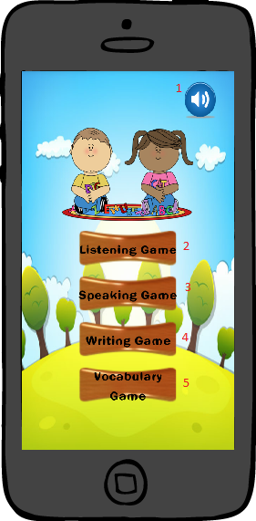

|  |  |  |  |  |
| --- | --- | --- | --- | --- |
| Button/Hyper Link | | | | |
| No. | **Function** | **Description** | **Validation** | **Outcome** |
| 1 | Turn on/off music | Turn off music when it’s in on status or turn on music when it’s in off status | N/A | Change music’s status |
| 2 | Play listening game | Go to list of some listening games | N/A | Navigate to “listening game menu screen” |
| 3 | Play speaking game | Go to speaking game screen. | N/A | Navigate to speaking game screen |
| 4 | Play writing game | Go to list of some writing games | N/A | Navigate to writing game screen |
| 5 | Play vocabulary game | Go to vocabulary game screen. | N/A | Navigate to vocabulary game screen |

## Listening game

### Listening game menu screen

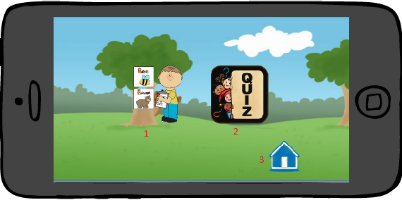

|  |  |  |  |  |
| --- | --- | --- | --- | --- |
| Button/Hyper Link | | | | |
| No. | **Function** | **Description** | **Validation** | **Outcome** |
| 1 | Play new words game | Go to “new words” game | No | Navigate to “new words menu screen” |
| 2 | Play multi choice game | Go to “multi choice” game | No | Navigate to “multi choice menu screen” |
| 3 | Back to “Home” | Go to “Main screen” | No | Navigate to “main screen” |

### New words game menu screen

### 

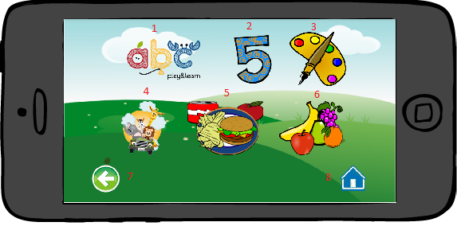

|  |  |  |  |  |
| --- | --- | --- | --- | --- |
| Button/Hyper Link | | | | |
| No. | **Function** | **Description** | **Validation** | **Outcome** |
| 1 | Play Alphabet new word | Go to “alphabet new words” | No | Navigate to “New words” game with “Alphabet” |
| 2 | Play Number new word | Go to “Number new words” | No | Navigate to “New words” game with “Number” |
| 3 | Play Color new word | Go to “Color new words” | No | Navigate to “New words” game with “Color” |
| 4 | Play Animal new words | Go to “Animal new words” | No | Navigate to “new words” game with “Animal” |
| 5 | Play Food new words | Go to “Food new words” | No | Navigate to “new words” game with “Food” |
| 6 | Play Fruit new words | Go to “Fruit new words” | No | Navigate to “new words” game with “Fruit” |
| 7 | Back to menu | Back to “Listening menu game” | No | Navigate to “Listening menu game screen” |
| 8 | Back to home | Back to “Main” | No | Navigate to “Main screen” |

#### New word game screen

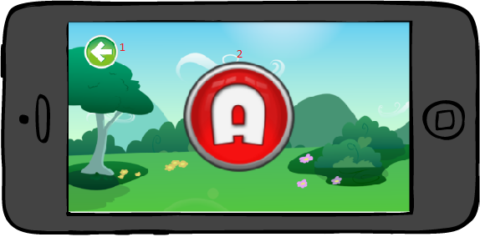

|  |  |  |  |  |  |  |
| --- | --- | --- | --- | --- | --- | --- |
| Fields | | | | | | |
| No. | **Name** | **Description** | **Mandatory** | **Control**  **Type** | **Data**  **Type** | **Length** |
| 2 | Image | Image with sound | No | Image Button | N/A | N/A |

|  |  |  |  |  |
| --- | --- | --- | --- | --- |
| Button/Hyper Link | | | | |
| No. | **Function** | **Description** | **Validation** | **Outcome** |
| 1 | Back to menu | Back to “New words game menu” | No | Navigate to “New words game menu screen” |

### Multi choice game menu screen



|  |  |  |  |  |
| --- | --- | --- | --- | --- |
| Button/Hyper Link | | | | |
| No. | **Function** | **Description** | **Validation** | **Outcome** |
| 1 | Play Alphabet multi choice | Go to “alphabet multi choice” | No | Navigate to “Multi choice” game with “Alphabet” |
| 2 | Play Number multi choice | Go to “Number multi choice” | No | Navigate to “Multi choice” game with “Number” |
| 3 | Play Color multi choice | Go to “Color multi choice” | No | Navigate to “Multi choice” game with “Color” |
| 4 | Play Animal multi choice | Go to “Animal multi choice” | No | Navigate to “Multi choice” game with “Animal” |
| 5 | Play Food multi choice | Go to “Food multi choice” | No | Navigate to “Multi choice” game with “Food” |
| 6 | Play Fruit multi choice | Go to “Fruit multi choice” | No | Navigate to “Multi choice” game with “Fruit” |
| 7 | Back to menu | Back to “Listening menu game” | No | Navigate to “Listening menu game screen” |
| 8 | Back to home | Back to “Main” | No | Navigate to “Main screen” |

#### Multi choice game screen

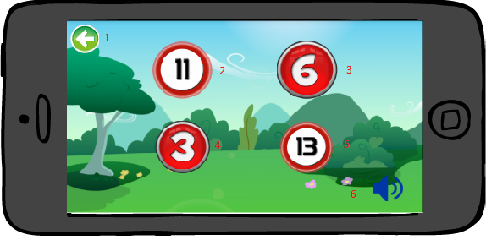

|  |  |  |  |  |
| --- | --- | --- | --- | --- |
| Button/Hyper Link | | | | |
| No. | **Function** | **Description** | **Validation** | **Outcome** |
| 1 | Back to menu | Back to “Multi choice game menu” | No | Navigate to “Multi choice game menu screen” |
| 2 | Answer1 | Answer 1 | No | Navigate to next question |
| 3 | Answer2 | Answer 2 | No | Navigate to next question |
| 4 | Answer3 | Answer 3 | No | Navigate to next question |
| 5 | Answer4 | Answer 4 | No | Navigate to next question |
| 6 | Replay sound | Replay sound | No | Replay sound of the question |

#### Listening multi choice result screen

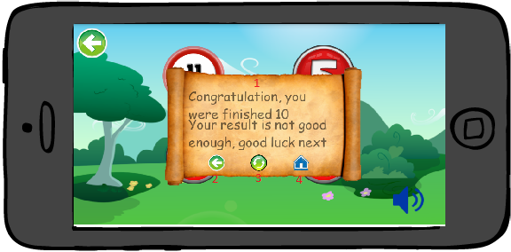

|  |  |  |  |  |  |  |
| --- | --- | --- | --- | --- | --- | --- |
| Fields | | | | | | |
| No. | **Name** | **Description** | **Mandatory** | **Control**  **Type** | **Data**  **Type** | **Length** |
| 1 | Result | Result of 10 question | No | Dialog | N/A | N/A |

|  |  |  |  |  |
| --- | --- | --- | --- | --- |
| Button/Hyper Link | | | | |
| No. | **Function** | **Description** | **Validation** | **Outcome** |
| 2 | Back to menu | Back to menu of multi choice game | No | Navigate to “Multi choice game menu screen” |
| 3 | Replay | Replay game | No | Replay game |
| 4 | Back to home | Back to listening game | No | Previous page |

## Speaking game

### Speaking game screen

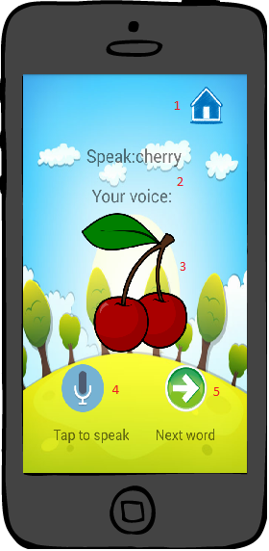

|  |  |  |  |  |  |  |
| --- | --- | --- | --- | --- | --- | --- |
| Fields | | | | | | |
| No. | **Name** | **Description** | **Mandatory** | **Control**  **Type** | **Data**  **Type** | **Length** |
| 2 | Question and answer | Show word required and word after speech | No | Text View | N/A | N/A |
| 3 | Image | Image with sound | No | Image button | N/A | N/A |

|  |  |  |  |  |
| --- | --- | --- | --- | --- |
| Button/Hyper Link | | | | |
| No. | **Function** | **Description** | **Validation** | **Outcome** |
| 1 | Back to home | Back to home page | No | Navigate to “Main screen” |
| 4 | Speech | Tap to speech | No | Show Speech Recognition |
| 5 | Next | Next question | No | Show the next question |

## Writing game

### Writing menu game screen

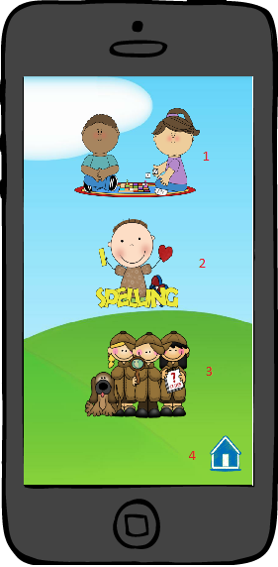

|  |  |  |  |  |
| --- | --- | --- | --- | --- |
| Button/Hyper Link | | | | |
| No. | **Function** | **Description** | **Validation** | **Outcome** |
| 1 | Play queue game | Go to “Queue” game | No | Navigate to “Queue game screen” |
| 2 | Play missing word game | Go to “Arrange word” game | No | Navigate to “Arrange word game screen” |
| 3 | Play arrange word game | Go to “Missing word” game | No | Navigate to “Missing word game screen” |
| 4 | Back to home | Back to home page | No | Back to “Main screen” |

### Queue game screen

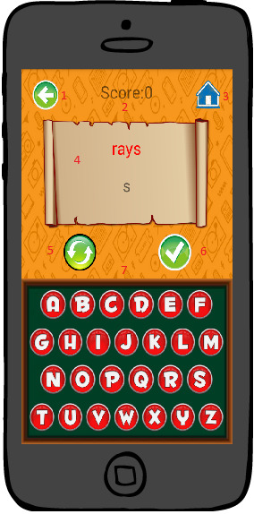

|  |  |  |  |  |  |  |
| --- | --- | --- | --- | --- | --- | --- |
| Fields | | | | | | |
| No. | **Name** | **Description** | **Mandatory** | **Control**  **Type** | **Data**  **Type** | **Length** |
| 2 | Score | Again score | No | Text View | N/A | N/A |
| 4 | Question and answer | Question and answer | No | Text View | N/A | N/A |
| 7 | Word | Suggest word | No | Image Button | N/A | N/A |

|  |  |  |  |  |
| --- | --- | --- | --- | --- |
| Button/Hyper Link | | | | |
| No. | **Function** | **Description** | **Validation** | **Outcome** |
| 1 | Back to menu | Back to menu of Writing game | No | Navigate to “Writing menu game screen” |
| 3 | Home | Back to main menu | No | Navigate to ”Main Screen ” |
| 5 | Reset | Reset answer of the question | No | Reset this question |
| 6 | Submit | Submit answer and go to next question | No | Go to next question |

### Queue game result

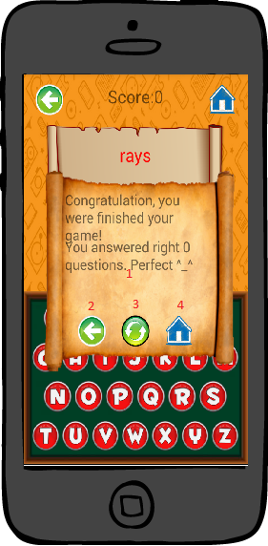

|  |  |  |  |  |  |  |
| --- | --- | --- | --- | --- | --- | --- |
| Fields | | | | | | |
| No. | **Name** | **Description** | **Mandatory** | **Control**  **Type** | **Data**  **Type** | **Length** |
| 1 | Result | Number of right question | No | Dialog | N/A | N/A |

|  |  |  |  |  |
| --- | --- | --- | --- | --- |
| Button/Hyper Link | | | | |
| No. | **Function** | **Description** | **Validation** | **Outcome** |
| 2 | Back to menu | Back to writing menu | No | Navigate to “Writing menu game screen” |
| 3 | Replay | Replay game | No | Replay game |
| 4 | Back to home | Back to listening game | No | Previous page |

### Arrange game screen

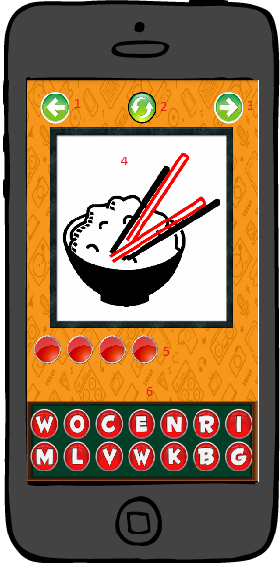

|  |  |  |  |  |  |  |
| --- | --- | --- | --- | --- | --- | --- |
| Fields | | | | | | |
| No. | **Name** | **Description** | **Mandatory** | **Control**  **Type** | **Data**  **Type** | **Length** |
| 4 | Image | Image | No | Image View | N/A | N/A |
| 5 | Answer | Show word has been chosen | No | Image View | N/A | N/A |
| 6 | Word | Suggest word | No | Image button | N/A | N/A |

|  |  |  |  |  |
| --- | --- | --- | --- | --- |
| Button/Hyper Link | | | | |
| No. | **Function** | **Description** | **Validation** | **Outcome** |
| 1 | Back to menu | Back to “Writing menu” | No | Navigate to “Writing menu game screen” |
| 2 | Refresh | Refresh the question | No | Refresh the question |
| 3 | Next | Skip this question | No | Go to next question |

### Arrange game result

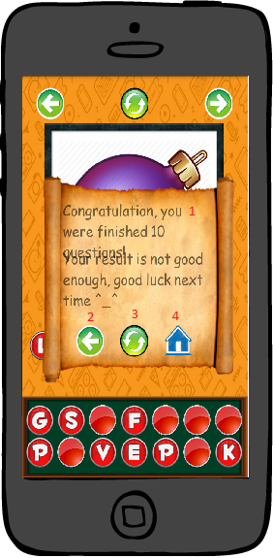

|  |  |  |  |  |  |  |
| --- | --- | --- | --- | --- | --- | --- |
| Fields | | | | | | |
| No. | **Name** | **Description** | **Mandatory** | **Control**  **Type** | **Data**  **Type** | **Length** |
| 1 | Result | Result of 10 question | No | Dialog | N/A | N/A |

|  |  |  |  |  |
| --- | --- | --- | --- | --- |
| Button/Hyper Link | | | | |
| No. | **Function** | **Description** | **Validation** | **Outcome** |
| 2 | Back to menu | Back to writing menu | No | Navigate to “Writing menu game screen” |
| 3 | Replay | Replay game | No | Replay game |
| 4 | Back to home | Back to listening game | No | Previous page |

### Missing word game screen

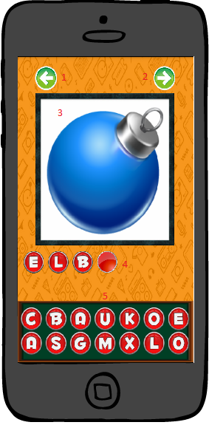

|  |  |  |  |  |  |  |
| --- | --- | --- | --- | --- | --- | --- |
| Fields | | | | | | |
| No. | **Name** | **Description** | **Mandatory** | **Control**  **Type** | **Data**  **Type** | **Length** |
| 4 | Image | Image | No | Image View | N/A | N/A |
| 5 | Answer | Show the answer | No | Image view | N/A | N/A |
| 6 | Word | Suggest word | No | Image button | N/A | N/A |

|  |  |  |  |  |
| --- | --- | --- | --- | --- |
| Button/Hyper Link | | | | |
| No. | **Function** | **Description** | **Validation** | **Outcome** |
| 1 | Back to menu | Back to “Writing menu” | No | Navigate to “Writing menu game screen” |
| 2 | Home | Back to home page | No | Navigate to “Main screen” |
| 3 | Next | Skip this question | No | Go to next question |

### Missing word game result



|  |  |  |  |  |  |  |
| --- | --- | --- | --- | --- | --- | --- |
| Fields | | | | | | |
| No. | **Name** | **Description** | **Mandatory** | **Control**  **Type** | **Data**  **Type** | **Length** |
| 1 | Result | Result of 10 question | No | Dialog | N/A | N/A |

|  |  |  |  |  |
| --- | --- | --- | --- | --- |
| Button/Hyper Link | | | | |
| No. | **Function** | **Description** | **Validation** | **Outcome** |
| 2 | Back to menu | Back to writing menu | No | Navigate to “Writing menu game screen” |
| 3 | Replay | Replay game | No | Replay game |
| 4 | Back to home | Back to listening game | No | Previous page |

## Vocabulary game

### Vocabulary game screen

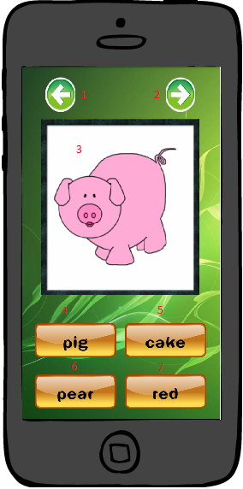

|  |  |  |  |  |  |  |
| --- | --- | --- | --- | --- | --- | --- |
| Fields | | | | | | |
| No. | **Name** | **Description** | **Mandatory** | **Control**  **Type** | **Data**  **Type** | **Length** |
| 3 | Image | Image | No | Image View | N/A | N/A |
| 4 | Answer1 | Suggest answer 1 | No | Image button | N/A | N/A |
| 5 | Answer2 | Suggest answer 2 | No | Image button | N/A | N/A |
| 6 | Answer3 | Suggest answer 3 | No | Image button | N/A | N/A |
| 7 | Answer4 | Suggest answer 4 | No | Image button | N/A | N/A |

|  |  |  |  |  |
| --- | --- | --- | --- | --- |
| Button/Hyper Link | | | | |
| No. | **Function** | **Description** | **Validation** | **Outcome** |
| 1 | Home | Back to home page | No | Navigate to “Main screen” |
| 2 | Next | Skip this question | No | Go to next question |

### Vocabulary game result

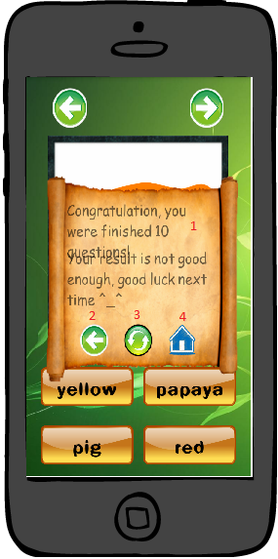

|  |  |  |  |  |  |  |
| --- | --- | --- | --- | --- | --- | --- |
| Fields | | | | | | |
| No. | **Name** | **Description** | **Mandatory** | **Control**  **Type** | **Data**  **Type** | **Length** |
| 1 | Result | Result of 10 question | No | Dialog | N/A | N/A |

|  |  |  |  |  |
| --- | --- | --- | --- | --- |
| Button/Hyper Link | | | | |
| No. | **Function** | **Description** | **Validation** | **Outcome** |
| 2 | Back to menu | Back to menu | No | Navigate to “Main screen” |
| 3 | Replay | Replay game | No | Replay game |
| 4 | Back to home | Back to listening game | No | Navigate to “Main screen” |

# V. Algorithm design

## Game play

### Listening game

#### New word game

* There are 2 array list:

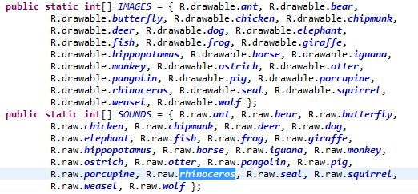

IMAGES array to save list of image to learn.

SOUNDS to save list of sound to listen.

* When user click on image, application will check index of this image in list then get the sound and name of this image. After that, application will play the sound and show text respective of this image.

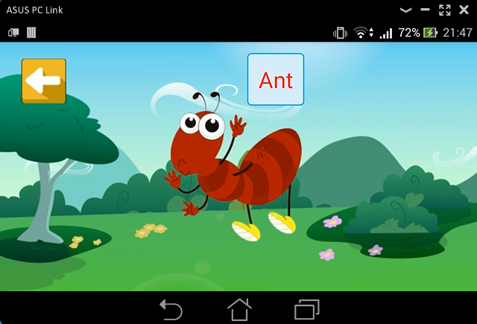

* Using SwipeEventDetected event to load next image.

#### Multi choice game

* There are 4 imagebuttons for answer and 1 default sound track in 1 question.

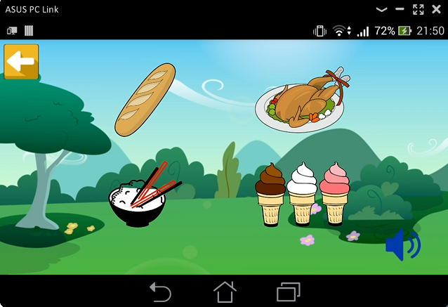

* There are 2 array lists Images and Sounds Question.

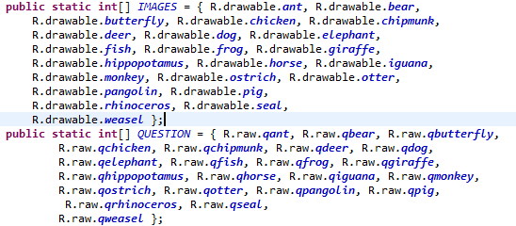

* Default sound will be random in Sounds Question list and play. Application will notice the index of this sound to check the answer is right or wrong.
* One answer image have image index and sound index in list, if this index is equal to random sound index the answer is right else the answer is wrong.

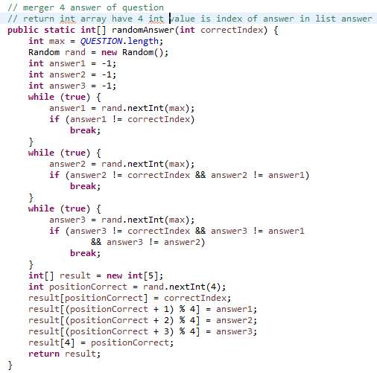

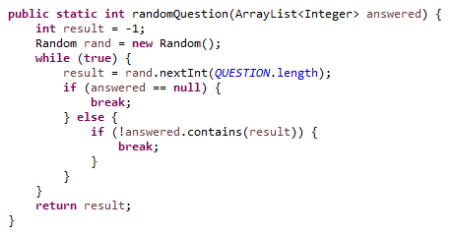

### Speaking game

* There is a text file contains a list of 10.000 English vocabularys.

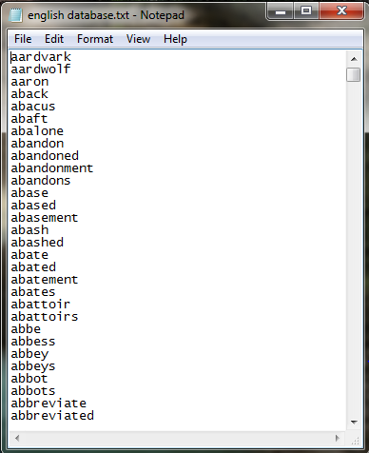

* When user start a game, the text file will load to strArr list to save word. FlagArr list is to check the word are not repeated.

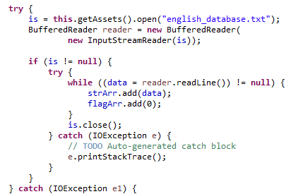

* Google speech API will recognize user’s speech and then change to text type. If this text is equal to word that user have to speak the answer is right else the application will show the user’s voice via Google speech API.

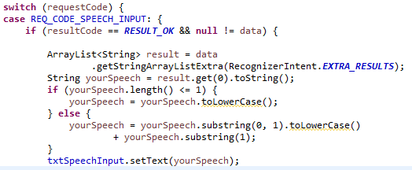

### Writing game

#### Queue game

* There is the text file haves 10.000 English vocabulary, we will read this text file and then save 10.000 vocabulary in array list.

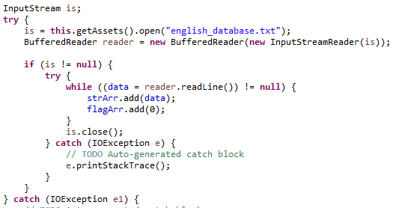

* Application will pick one random word in this list and show to the screen.
* User will fill input to edittext field. Application will check 2 things, the first one is this word must be appear in 10.000 word list and the second one is first character of user’s input is equal to last character of application word.
* For example: computer’s input is “school”, user’s input must be start with letter ”l” such as “listen” or “last”

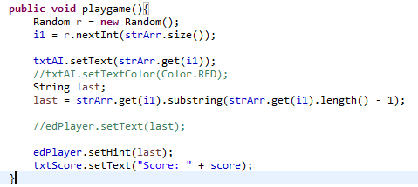

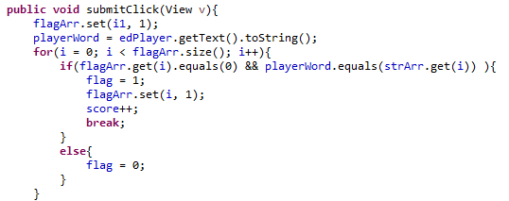

#### Arrange word game

* There is an image list, when image was loaded random in image list we will have the index of this image so we can get the word of this image by name.
* We put the character in the edittext field one by one but wrong order character. If user’s input is equal to initial word the answer is right else the answer is wrong.

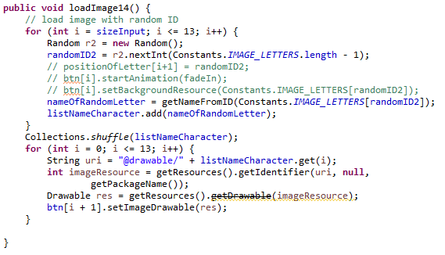

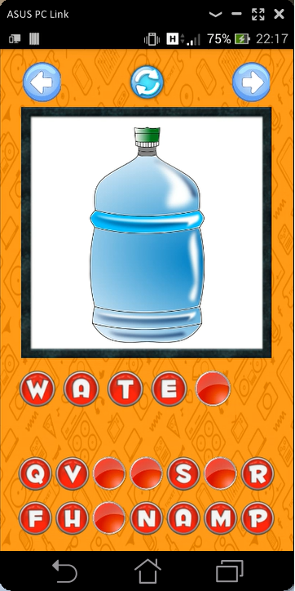

#### Missing word game

* There is an image list, when image is loaded random in image list we will have the index of this image so we can get the word of this image by name.
* We put the character in the edit text field one by one but miss one character. We will notice this miss character to one variable and will compare with user’s input. If user’s input is equal to missing character the answer is right else the answer is wrong.

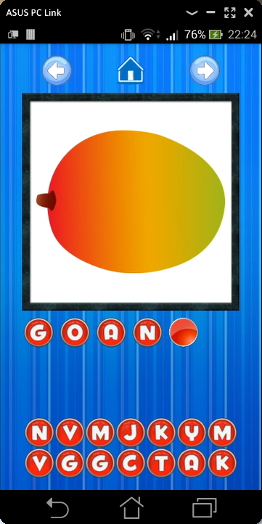

### Vocabulary game

* There is an image list, when image is loaded random in image list we will have the index of this image so we can get the word of this image by name.
* Get 3 random words in database and make it to be multi choice answer with 1 right answer.

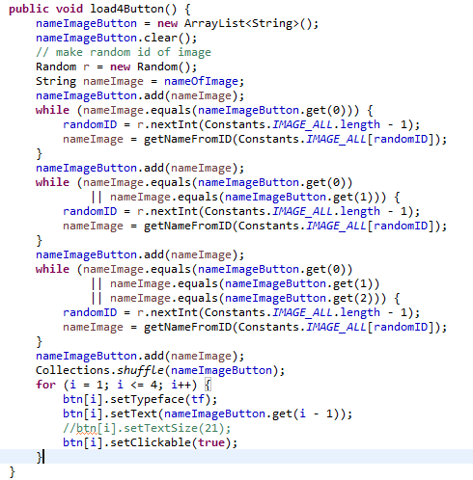

* Application will check if user’s answer is equal to right word the answer is right else the answer is wrong.

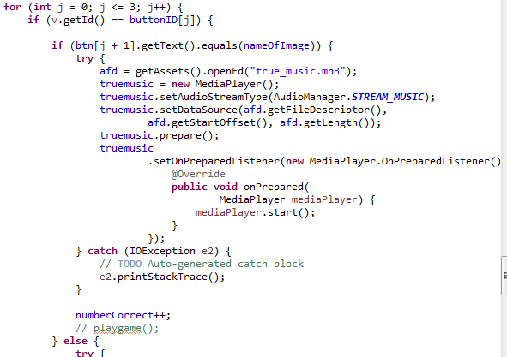

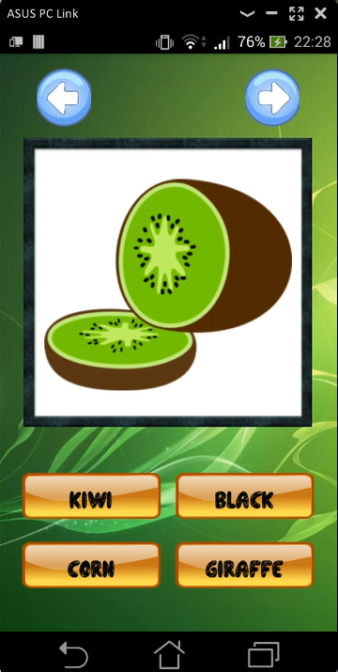

## Non function Algorithm

### Multi-Language Support

By default android considers English as primary language and loads the string resources from **res ⇒ values ⇒ strings.xml**.

Now we want to add support for another language, we need to create a values folder by appending a Hyphen and the ISO language code.

For example we add support for **French**, we create a values folder named **values-fr** and keep a **strings.xml** file in it with all the strings translated into French language.

This table is name of some different language res folder:

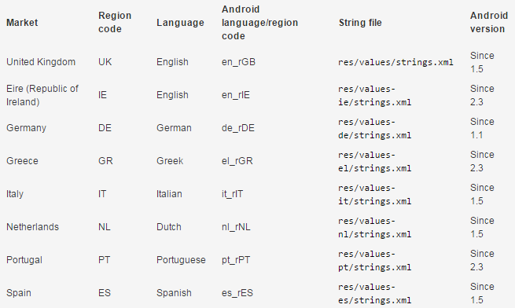

And this is one example of **string** file

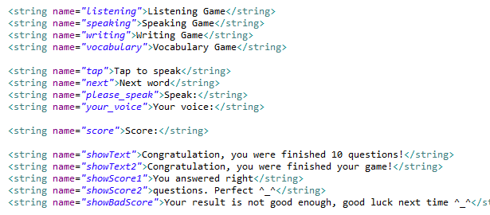

Thai language supported string file:

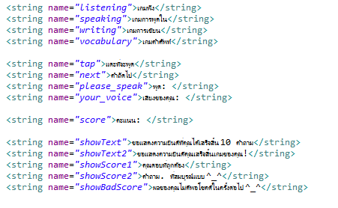

### Multi-Screen size Support

We will use percent library for create android layout.

This is one example how to use percent library to create layout in android app:

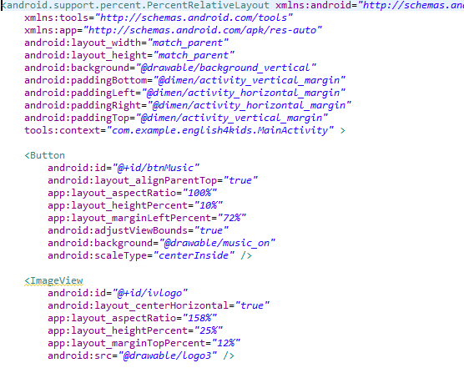

# VI. System Implementation & Test

## Introduction

### Overview

This document is test report for English for Kid app. It contains the following sections:

* + Introduction: giving an overview of the project as well as scope of testing.
  + Test approach: include test type, test level and test stages
  + Feature to be tested
  + Feature not to be tested
  + Testing tools
  + Testing environment
  + Test case
  + Checklist

### Test Approach

#### Test type

##### Function Testing

* + Testing of all implemented functions on the E4K app.
  + The testing that will be covered for those functions in function test is verification the validation of the behavior according to requirements.
  + Test cases will have to be designed to cover all the above and executed.
  + Implemented functions’ error messages will be included under this test.
  + Loading data measurement also known as start-up performance will be performed by checking on the response time for read and write data on application.

##### User Interface Testing

* + GUI test will be performed fully on all screens.
  + This test is targeted to cover the verification of the overall look and feel of the E4K app including initial position, font, text size, color, focus, initial button, label, screen sizes and sentences width.

#### Test level

**Unit Testing** will be done by the developer and tester partner and will be approved by the development team leader. Proof of unit testing (test case list, sample output, data printouts, defect information must be provided by the programmer to the team leader before unit testing will be accepted and passed on to the test person. All unit test information will also be provided to the test person.

**Integration Testing** will be performed by the test manager and tester. No specific test tools are available for this project. Programs will enter into System/Integration test after all critical defects have been corrected. Test cases will have to be designed to cover all the above and executed. Proof of System/Integration Testing: Test case list, test result, test report, check list, etc… The Integration test will be done in parallel with E4K app development process for a period of four month.

**System Testing** will be performed by the test manager and tester. No specific test tools are available for this project. Programs will enter into System test after all critical defects have been corrected. Test cases will have to be designed to cover all the above and executed. Proof of System Testing: Test case list, test result, test report, check list, etc…The System test will be done in for a period of 5 days after completion of the Integration test process.

#### Test stages

**Testing model**

Scrum Model

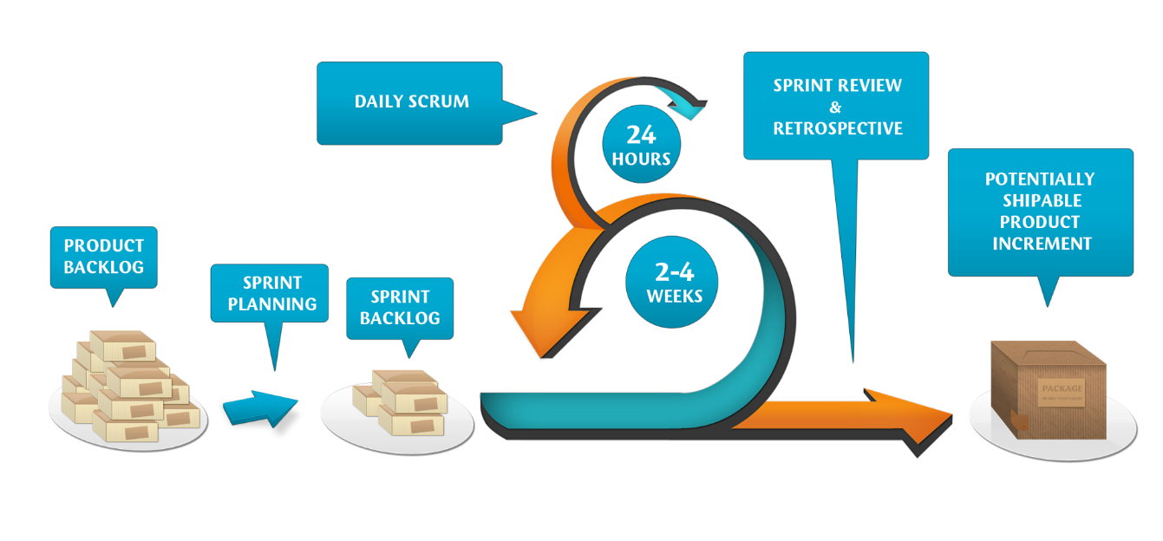

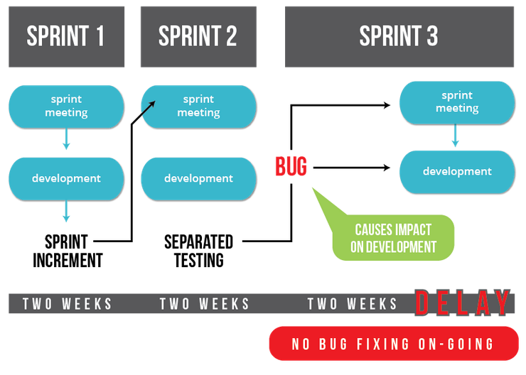

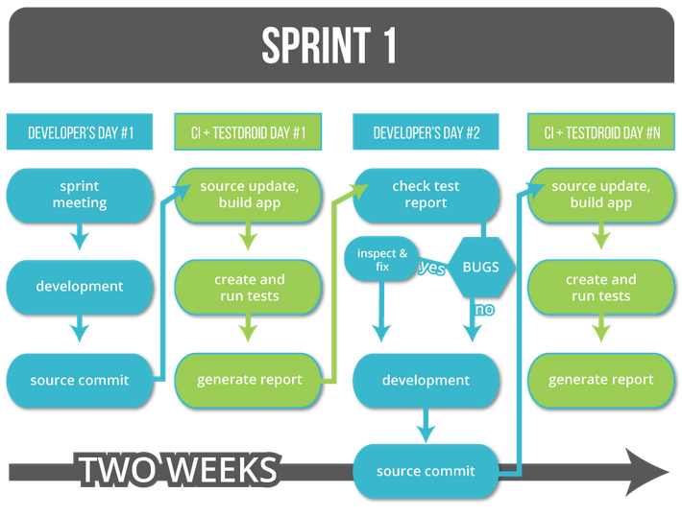

## Test Plan

### Features to be tested

#### Functional feature

|  |  |  |
| --- | --- | --- |
| **No.** | **Use-case Name** | **Summary** |
| UC001 | Pick game | Allows users pick kind of game |
| UC002 | Pick topic | Allows users pick a topic |
| UC003 | Choose answer | Allows users choose an answer |
| UC004 | View result | Allows users view result |
| UC005 | Replay | Allows users replay game |
| UC006 | Listen | Allows users listen new words |
| UC007 | Listen again | Allows users listen new word again |
| UC008 | Speak | Allows users speak |
| UC009 | Speak again | Allows users speak again |
| UC010 | Change question | Allows users change question |
| UC011 | Write text | Allows users write text |
| UC012 | Fill text | Allows users to fill character missing |
| UC013 | Write text | Allows users write text |
| UC014 | Turn on music | Allows user turn on music |
| UC015 | Turn off music | Allows users turn of music |

#### Non-functional features for application

* GUI:
* The interface must be clear, visual and simple.
* Usability for users:
* The user’s interface has to friendly, easy to use on each function.
* Application must attract the giddy, eager curious and leanr of children.

### Features not to be tested

* Performance testing
* Scalability Testing
* Volume testing

### Testing Tools and Environment

#### Testing tools:

|  |  |  |  |
| --- | --- | --- | --- |
| **Purpose** | **Tool** | **Vendor/In-house** | **Version** |
| Test Plan | MS Word | Microsoft | 2010 |
| Test Case | MS Excel | Microsoft | 2010 |
| Apps Screen | Android Mobile | Google | Android 4.4 |
| Test report | MS Excel | Microsoft | 2010 |
| Unit Test | Manual Test |  |  |

#### Testing environment

|  |  |  |  |
| --- | --- | --- | --- |
| **Purpose** | **Environment** | **Vendor/In-house** | **Version** |
| Unit Test | Android Mobile | Google |  |
| Database develop |  |  |  |

## Test cases

|  |  |  |  |  |  |  |
| --- | --- | --- | --- | --- | --- | --- |
| **No** | **Module code** | **Pass** | **Fail** | **Untested** | **N/A** | **Number of test cases** |
| 1 | Module 1 | 13 | 0 | 0 | 0 | 13 |
| 2 | Module 2 | 13 | 0 | 0 | 0 | 13 |
| 3 | Module 3 | 3 | 0 | 0 | 0 | 3 |
| 4 | Module 4 | 7 | 0 | 0 | 0 | 7 |
| 5 | Module 5 | 22 | 0 | 0 | 0 | 22 |
| 6 | Module 6 | 7 | 0 | 0 | 0 | 7 |
| 7 | Module 7 | 10 | 0 | 0 | 0 | 10 |
| 8 | Module 8 | 17 | 0 | 0 | 0 | 17 |
| 9 | Module 9 | 18 | 0 | 0 | 0 | 18 |
|  | **Sub total** | 110 | 0 | 0 | 0 | 110 |
|  |  |  |  |  |  |  |
|  | **Test coverage** | | **100.00** | % |  |  |
|  | **Test successful coverage** | | **100.00** | % |  |  |

|  |  |  |
| --- | --- | --- |
| **No** | **Function Name** | **Sheet Name** |
| 1 | Play Sound | Module 1 |
| 2 | Record Voice | Module 2 |
| 3 | Fill Word | Module 3 |
| 4 | Select Answer | Module 4 |
| 5 | Display | Module 5 |
| 6 | Home | Module 6 |
| 7 | Next | Module 7 |
| 8 | Replay | Module 8 |
| 9 | Back | Module 9 |
| 10 | Turn on/off | Module 2 |
| 12 | Sum up | Module 2 |

### Module 1

|  |  |  |  |  |  |  |  |
| --- | --- | --- | --- | --- | --- | --- | --- |
| **ID** | **Test Case Description** | **Test Case Procedure** | **Expected Output** | **Inter-test case Dependence** | **Result** | **Test date** | **Note** |
|  | **Play Sound** |  |  |  |  |  |  |
| [Module 1-1] | Test pronunciation of a letter | 1. Open application 2.Tap on 'Listening Game' 3. Tap on 'new word' icon 4. Tap on letter icon 5. Tap on letter image | 1. Make a sound of this letter pronunciation |  | Pass |  |  |
| [Module 1-2] | Test pronunciation of a number | 1. Open application 2.Tap on 'Listening Game' 3. Tap on 'new word' icon 4. Tap on number icon 5. Tap on number image | 1. Make a sound of this number pronunciation |  | Pass |  |  |
| [Module 1-3] | Test pronunciation of a color | 1. Open application 2.Tap on 'Listening Game' 3. Tap on 'new word' icon 4. Tap on color icon 5. Tap on color image | 1. Make a sound of this color pronunciation |  | Pass |  |  |
| [Module 1-4] | Test pronunciation of an animal | 1. Open application 2.Tap on 'Listening Game' 3. Tap on 'new word' icon 4. Tap on animal icon 5. Tap on animal image | 1. Make a sound of this animal pronunciation |  | Pass |  |  |
| [Module 1-5] | Test pronunciation of a kind of food | 1. Open application 2.Tap on 'Listening Game' 3. Tap on 'new word' icon 4. Tap on food icon 5. Tap on food image | 1. Make a sound of this food pronunciation |  | Pass |  |  |
| [Module 1-6] | Test pronunciation of a kind of fruit | 1. Open application 2.Tap on 'Listening Game' 3. Tap on 'new word' icon 4. Tap on fruit icon 5. Tap on fruit image | 1. Make a sound of this fruit pronunciation |  | Pass |  |  |
| [Module 1-7] | Test letter question sound | 1. Open application 2.Tap on 'Listening Game' 3. Tap on 'multi choice' icon 4. Tap on letter icon | 1. Make a sound of question |  | Pass |  |  |
| [Module 1-8] | Test number question sound | 1. Open application 2.Tap on 'Listening Game' 3. Tap on 'multi choice' icon 4. Tap on number icon | 1. Make a sound of question |  | Pass |  |  |
| [Module 1-9] | Test color question sound | 1. Open application 2.Tap on 'Listening Game' 3. Tap on 'multi choice' icon 4. Tap on color icon | 1. Make a sound of question |  | Pass |  |  |
| [Module 1-10] | Test animals question sound | 1. Open application 2.Tap on 'Listening Game' 3. Tap on 'multi choice' icon 4. Tap on animals icon | 1. Make a sound of question |  | Pass |  |  |
| [Module 1-11] | Test food question sound | 1. Open application 2.Tap on 'Listening Game' 3. Tap on 'multi choice' icon 4. Tap on food icon | 1. Make a sound of question |  | Pass |  |  |
| [Module 1-12] | Test fruits question sound | 1. Open application 2.Tap on 'Listening Game' 3. Tap on 'multi choice' icon 4. Tap on fruits icon | 1. Make a sound of question |  | Pass |  |  |
| [Module 1-13] | Test word pronunciation | 1. Open application 2.Tap on 'Speaking Game' 3. Tap on image | 1. Make a sound of pronunciation of the thing in image |  | Pass |  |  |

### Module 2

|  |  |  |  |  |  |  |  |
| --- | --- | --- | --- | --- | --- | --- | --- |
| **ID** | **Test Case Description** | **Test Case Procedure** | **Expected Output** | **Inter-test case Dependence** | **Result** | **Test date** | **Note** |
|  | **RecordVoice** |  |  |  |  |  |  |
| [Module 2-1] | Test recording speaking voice | 1. Open application 2. Tap on 'Speaking Game' 3. Tap on 'Tap to speak' button 4. Speak aloud | 1. Get the record of speaking voice 2. Save the record to data |  | Pass |  |  |
|  | **Turn on/off** |  |  |  |  |  |  |
| [Module 2-2] | Turn on music game | 1. Open application 2. Tap on sound icon | 1. Background music of the game is on |  | Pass |  |  |
| [Module 2-3] | Turn off music game | 1. Open application 2. Tap on sound icon | 1. Background music of the game is off |  | Pass |  |  |
|  | **Sum up** |  |  |  |  |  |  |
| [Module 2-4] | Test displaying sum up letter | 1. Open application 2. Tap on 'Listening Game' 3. Tap on multi choice icon 4. Tap on letter icon 5. Finish 10 questions | 1. Display information following: - Number of questions done - Number of true answers if true answers greater than 6 - A statement |  | Pass |  |  |
| [Module 2-5] | Test displaying sum up number | 1. Open application 2. Tap on 'Listening Game' 3. Tap on multi choice icon 4. Tap on number icon 5. Finish 10 questions | 1. Display information following: - Number of questions done - Number of true answers if true answers greater than 6 - A statement |  | Pass |  |  |
| [Module 2-6] | Test displaying sum up color | 1. Open application 2. Tap on 'Listening Game' 3. Tap on multi choice icon 4. Tap on color icon 5. Finish 10 questions | 1. Display information following: - Number of questions done - Number of true answers if true answers greater than 6 - A statement |  | Pass |  |  |
| [Module 2-7] | Test displaying sum up animal | 1. Open application 2. Tap on 'Listening Game' 3. Tap on multi choice icon 4. Tap on animal icon 5. Finish 10 questions | 1. Display information following: - Number of questions done - Number of true answers if true answers greater than 7 - A statement |  | Pass |  |  |
| [Module 2-8] | Test displaying sum up food | 1. Open application 2. Tap on 'Listening Game' 3. Tap on multi choice icon 4. Tap on food icon 5. Finish 10 questions | 1. Display information following: - Number of questions done - Number of true answers if true answers greater than 6 - A statement |  | Pass |  |  |
| [Module 2-9] | Test displaying sum up fruit | 1. Open application 2. Tap on 'Listening Game' 3. Tap on multi choice icon 4. Tap on fruit icon 5. Finish 10 questions | 1. Display information following: - Number of questions done - Number of true answers if true answers greater than 6 - A statement |  | Pass |  |  |
| [Module 2-10] | Test displaying sum up from queue word | 1. Open application 2. Tap on 'Writing Game' 3. Tap on queue word icon 4. Answer wrong | Show number of true answers |  | Pass |  |  |
| [Module 2-11] | Test displaying sum up from filling word | 1. Open application 2. Tap on 'Writing Game' 3. Tap on fill word icon 4. Finish 10 questions | 1. Display information following: - Number of questions done - Number of true answers if true answers greater than 6 - A statement |  | Pass |  |  |
| [Module 2-12] | Test displaying sum up from missing word | 1. Open application 2. Tap on 'Writing Game' 3. Tap on missing word icon 4. Finish 10 questions | 1. Display information following: - Number of questions done - Number of true answers if true answers greater than 6 - A statement |  | Pass |  |  |
| [Module 2-13] | Test displaying sum up from vocabulary | 1. Open application 2. Tap on 'Vocabulary Game' 3. Finish 10 questions | 1. Display information following: - Number of questions done - Number of true answers if true answers greater than 6 - A statement |  | Pass |  |  |

### Module 3

|  |  |  |  |  |  |  |  |
| --- | --- | --- | --- | --- | --- | --- | --- |
| **ID** | **Test Case Description** | **Test Case Procedure** | **Expected Output** | **Inter-test case Dependence** | **Result** | **Test date** | **Note** |
|  | **FillWord** |  |  |  |  |  |  |
| [Module 3-1] | Test filling characters queue of a word | 1. Open application 2. Tap on 'Writing Game' 3. Tap on queue word icon 4. Tap on letter icon until input enough character of a word 5. Tap check icon | 1. Every character moves from its default place into blank place 2. Make an alarm sound for a correct or incorrect word after input word 3. Automatically move to next word |  | Pass |  |  |
| [Module 3-2] | Test filling all characters of a word | 1. Open application 2. Tap on 'Writing Game' 3. Tap on fill word icon 4. Tap on letter icon until filling full character of a word | 1. Every character moves from its default place into blank place 2. Make an alarm sound for a correct or incorrect word after filling up blank places 3. Automatically move to next word |  | Pass |  |  |
| [Module 3-3] | Test filling missing character | 1. Open application 2. Tap on 'Writing Game' 3. Tap on find missing character icon 4. Tap on letter icon 1 time | 1. Make an alarm sound for a correct or incorrect word 3. Automatically move to next word |  | Pass |  |  |

### Module 4

|  |  |  |  |  |  |  |  |
| --- | --- | --- | --- | --- | --- | --- | --- |
| **ID** | **Test Case Description** | **Test Case Procedure** | **Expected Output** | **Inter-test case Dependence** | **Result** | **Test date** | **Note** |
|  | **Select Answer** | |  |  |  |  |  |
| [Module 4-1] | Test choosing an answer for question about letter | 1. Open application 2. Tap on 'Listening Game' 3. Tap on letter icon 4. Tap on one of four letter options | 1. Make an alarm sound for correct or incorrect answer 2. Automatically move to next question |  | Pass |  |  |
| [Module 4-2] | Test choosing an answer for question about number | 1. Open application 2. Tap on 'Listening Game' 3. Tap on number icon 4. Tap on one of four number options | 1. Make an alarm sound for correct or incorrect answer 2. Automatically move to next question |  | Pass |  |  |
| [Module 4-3] | Test choosing an answer for question about color | 1. Open application 2. Tap on 'Listening Game' 3. Tap on color icon 4. Tap on one of four color options | 1. Make an alarm sound for correct or incorrect answer 2. Automatically move to next question |  | Pass |  |  |
| [Module 4-4] | Test choosing an answer for question about animals | 1. Open application 2. Tap on 'Listening Game' 3. Tap on animals icon 4. Tap on one of four animals options | 1. Make an alarm sound for correct or incorrect answer 2. Automatically move to next question |  | Pass |  |  |
| [Module 4-5] | Test choosing an answer for question about food | 1. Open application 2. Tap on 'Listening Game' 3. Tap on food icon 4. Tap on one of four food options | 1. Make an alarm sound for correct or incorrect answer 2. Automatically move to next question |  | Pass |  |  |
| [Module 4-6] | Test choosing an answer for question about fruits | 1. Open application 2. Tap on 'Listening Game' 3. Tap on fruits icon 4. Tap on one of four fruit options | 1. Make an alarm sound for correct or incorrect answer 2. Automatically move to next question |  | Pass |  |  |
| [Module 4-7] | Test choosing an answer for question about thing in picture | 1. Open application 2. Tap on 'Vocabulary Game' 3. Tap on fruits icon 4. Tap on one of four options | 1. Make an alarm sound for correct or incorrect answer 2. Automatically move to next question |  | Pass |  |  |

### Module 5

|  |  |  |  |  |  |  |  |
| --- | --- | --- | --- | --- | --- | --- | --- |
| **ID** | **Test Case Description** | **Test Case Procedure** | **Expected Output** | **Inter-test case Dependence** | **Result** | **Test date** | **Note** |
|  | **Display** |  |  |  |  |  |  |
| [Module 5-1] | Test displaying main screen | 1. Open application | 1. Display 4 parts of the game include: - Listening Game - Speaking Game - Writing Game - Vocabulary Game 2. Display a sound icon |  | Pass |  |  |
| [Module 5-2] | Test Listening main screen | 1. Open application 2. Tap on 'Listening Game' | 1. Display 3 topics for listening includes: - New word - Multi choice - Cart 2. Display a home icon |  | Pass |  |  |
| [Module 5-3] | Test displaying topic for new word part of listening | 1. Open application 2. Tap on 'Listening Game' 3. Tap on new word icon | 1. Display 6 topics following: - Letter - Number - Color - Animal - Food - Fruit |  | Pass |  |  |
| [Module 5-4] | Test displaying topic for multi choice part of listening | 1. Open application 2. Tap on 'Listening Game' 3. Tap on multi choice icon | 1. Display 6 topics following: - Letter - Number - Color - Animal - Food - Fruit |  | Pass |  |  |
| [Module 5-5] | Test displaying a letter for listening | 1. Open application 2. Tap on 'Listening Game' 3. Tap on new word icon 4. Tap on letter icon | 1. Display a letter image 2. Display a back icon |  | Pass |  |  |
| [Module 5-6] | Test displaying a number for listening | 1. Open application 2. Tap on 'Listening Game' 3. Tap on new word icon 4. Tap on number icon | 1. Display a number image 2. Display a back icon |  | Pass |  |  |
| [Module 5-7] | Test displaying a color for listening | 1. Open application 2. Tap on 'Listening Game' 3. Tap on new word icon 4. Tap on color icon | 1. Display a color image 2. Display a back icon |  | Pass |  |  |
| [Module 5-8] | Test displaying an animal for listening | 1. Open application 2. Tap on 'Listening Game' 3. Tap on new word icon 4. Tap on animal icon | 1. Display an animal image 2. Display a back icon |  | Pass |  |  |
| [Module 5-9] | Test displaying a food for listening | 1. Open application 2. Tap on 'Listening Game' 3. Tap on new word icon 4. Tap on food icon | 1. Display a food image 2. Display a back icon |  | Pass |  |  |
| [Module 5-10] | Test displaying a fruit for listening | 1. Open application 2. Tap on 'Listening Game' 3. Tap on new word icon 4. Tap on fruit icon | 1. Display a fruit image 2. Display a back icon |  | Pass |  |  |
| [Module 5-11] | Test displaying letter options for listening question | 1. Open application 2. Tap on 'Listening Game' 3. Tap on multi choice icon 4. Tap on letter icon | 1. Display four letter options 2. Display a back icon 3. Display replay sound icon |  | Pass |  |  |
| [Module 5-12] | Test displaying number options for listening question | 1. Open application 2. Tap on 'Listening Game' 3. Tap on multi choice icon 4. Tap on number icon | 1. Display four number options 2. Display a back icon 3. Display replay sound icon |  | Pass |  |  |
| [Module 5-13] | Test displaying color options for listening question | 1. Open application 2. Tap on 'Listening Game' 3. Tap on multi choice icon 4. Tap on color icon | 1. Display four color options 2. Display a back icon 3. Display replay sound icon |  | Pass |  |  |
| [Module 5-14] | Test displaying animal options for listening question | 1. Open application 2. Tap on 'Listening Game' 3. Tap on multi choice icon 4. Tap on animal icon | 1. Display four animal options 2. Display a back icon 3. Display replay sound icon |  | Pass |  |  |
| [Module 5-15] | Test displaying food options for listening question | 1. Open application 2. Tap on 'Listening Game' 3. Tap on multi choice icon 4. Tap on food icon | 1. Display four food options 2. Display a back icon 3. Display replay sound icon |  | Pass |  |  |
| [Module 5-16] | Test displaying fruit options for listening question | 1. Open application 2. Tap on 'Listening Game' 3. Tap on multi choice icon 4. Tap on fruit icon | 1. Display four fruit options 2. Display a back icon 3. Display replay sound icon |  | Pass |  |  |
| [Module 5-17] | Test Speaking main screen | 1. Open application 2. Tap on 'Speaking Game' | 1. Display information includes: - Image - Word of image - Word of user pronunciation 2. Display 'Tap to speak' button 3. Display 'Next word' button 4. Display a home icon |  | Pass |  |  |
| [Module 5-18] | Test Writing main screen | 1. Open application 2. Tap on 'Writing Game' | 1. Display 3 topics for writing includes: - New word - Fill word - Fill missing character of word 2. Display a home icon |  | Pass |  |  |
| [Module 5-19] | Test queue word screen | 1. Open application 2. Tap on 'Writing Game' 3. Tap on queue word icon | 1. Display an word question 2. Display keybroad 3. Display places for filling character 4. Display 3 icon following: - Back - Replay - Check |  | Pass |  |  |
| [Module 5-20] | Test fill word screen | 1. Open application 2. Tap on 'Writing Game' 3. Tap on fill word icon | 1. Display an image 2. Display 14 letters 3. Display blank places for filling character 4. Display 3 icon following: - Back - Replay - Next |  | Pass |  |  |
| [Module 5-21] | Test fill a character screen | 1. Open application 2. Tap on 'Writing Game' 3. Tap on fill missing character icon | 1. Display an image 2. Display 14 letters 3. Display characters of word with missing a letter 4. Display 3 icon following: - Back - Home - Next |  | Pass |  |  |
| [Module 5-22] | Test Vocabulary screen | 1. Open application 2. Tap on 'Vocabulary Game' | 1. Display an image 2. Display 4 options for choosing 4. Display 2 icons include: - Back - Next |  | Pass |  |  |

### Module 6

|  |  |  |  |  |  |  |  |
| --- | --- | --- | --- | --- | --- | --- | --- |
| **ID** | **Test Case Description** | **Test Case Procedure** | **Expected Output** | **Inter-test case Dependence** | **Result** | **Test date** | **Note** |
|  | **Home** |  |  |  |  |  |  |
| [Module 6-1] | Test home function of Listening main screen | 1. Open application 2. Tap on 'Listening Game' 3. Tap on home icon | 1. Display main screen |  | Pass |  |  |
| [Module 6-2] | Test home function of Listening new word screen | 1. Open application 2. Tap on 'Listening Game' 3. Tap on new word icon 4. Tap on home icon | 1. Display main screen |  | Pass |  |  |
| [Module 6-3] | Test home function of Listening multi choice screen | 1. Open application 2. Tap on 'Listening Game' 3. Tap on multi choice icon 4. Tap on home icon | 1. Display main screen |  | Pass |  |  |
| [Module 6-4] | Test home function of Speaking screen | 1. Open application 2. Tap on 'Speaking Game' 3. Tap on home icon | 1. Display main screen |  | Pass |  |  |
| [Module 6-5] | Test home function of Writing main screen | 1. Open application 2. Tap on 'Writing Game' 3. Tap on home icon | 1. Display main screen |  | Pass |  |  |
| [Module 6-6] | Test home function of Writing main screen | 1. Open application 2. Tap on 'Writing Game' 3. Tap on queue game icon 4. Tap on home icon | 1. Display main screen |  | Pass |  |  |
| [Module 6-7] | Test home of filling missing character screen | 1. Open application 2. Tap on 'Writing Game' 3. Tap on fill missing character icon 4. Tap on home icon | 1. Display main screen |  | Pass |  |  |

### Module 7

|  |  |  |  |  |  |  |  |
| --- | --- | --- | --- | --- | --- | --- | --- |
| **ID** | **Test Case Description** | **Test Case Procedure** | **Expected Output** | **Inter-test case Dependence** | **Result** | **Test date** | **Note** |
|  | **Next** |  |  |  |  |  |  |
| [Module 7-1] | Test next a letter | 1. Open application 2. Tap on 'Listening Game' 3. Tap on new word icon 4. Tap on letter icon 5. Touch and hold letter image, then move to left | 1. Display next letter image |  | Pass |  |  |
| [Module 7-2] | Test next a number | 1. Open application 2. Tap on 'Listening Game' 3. Tap on new word icon 4. Tap on number icon 5. Touch and hold number image, then move to left | 1. Display next number image |  | Pass |  |  |
| [Module 7-3] | Test next a color | 1. Open application 2. Tap on 'Listening Game' 3. Tap on new word icon 4. Tap on color icon 5. Touch and hold color image, then move to left | 1. Display next color image |  | Pass |  |  |
| [Module 7-4] | Test next an animal | 1. Open application 2. Tap on 'Listening Game' 3. Tap on new word icon 4. Tap on animal icon 5. Touch and hold animal image, then move to left | 1. Display next animal image |  | Pass |  |  |
| [Module 7-5] | Test next a food | 1. Open application 2. Tap on 'Listening Game' 3. Tap on new word icon 4. Tap on food icon 5. Touch and hold food image, then move to left | 1. Display next food image |  | Pass |  |  |
| [Module 7-6] | Test next a fruit | 1. Open application 2. Tap on 'Listening Game' 3. Tap on new word icon 4. Tap on fruit icon 5. Touch and hold fruit image, then move to left | 1. Display next fruit image |  | Pass |  |  |
| [Module 7-7] | Test next a picture | 1. Open application 2. Tap on 'Speaking Game' 3. Tap on 'Next word' button | 1. Display next picture |  | Pass |  |  |
| [Module 7-8] | Test next a question in filling word screen | 1. Open application 2. Tap on 'Writing Game' 3. Tap on fill word icon 4. Tap on next icon | 1. Display new question following: - New picture - New characters |  | Pass |  |  |
| [Module 7-9] | Test next a question in filling missing character screen | 1. Open application 2. Tap on 'Writing Game' 3. Tap on fill missing word icon 4. Tap on next icon | 1. Display new question following: - New picture - New characters |  | Pass |  |  |
| [Module 7-10] | Test next in vocabulary screen | 1. Open application 2. Tap on 'Vocabulary Game' 3. Tap on next icon | 1. Display new picture 2. Display 4 new options |  | Pass |  |  |

### Module 8

|  |  |  |  |  |  |  |  |
| --- | --- | --- | --- | --- | --- | --- | --- |
| **ID** | **Test Case Description** | **Test Case Procedure** | **Expected Output** | **Inter-test case Dependence** | **Result** | **Test date** | **Note** |
|  | **Replay** |  |  |  |  |  |  |
| [Module 8-1] | Test replaying sound of a letter | 1. Open application 2. Tap on 'Listening Game' 3. Tap on new word icon 4. Tap on letter icon 5. Tap on letter image | 1. Make a sound of letter pronunciation again |  | Pass |  |  |
| [Module 8-2] | Test replaying sound of a number | 1. Open application 2. Tap on 'Listening Game' 3. Tap on new word icon 4. Tap on number icon 5. Tap on number image | 1. Make a sound of number pronunciation again |  | Pass |  |  |
| [Module 8-3] | Test replaying sound of a color | 1. Open application 2. Tap on 'Listening Game' 3. Tap on new word icon 4. Tap on color icon 5. Tap on color image | 1. Make a sound of color pronunciation again |  | Pass |  |  |
| [Module 8-4] | Test replaying sound of an animal | 1. Open application 2. Tap on 'Listening Game' 3. Tap on new word icon 4. Tap on animal icon 5. Tap on animal image | 1. Make a sound of animal pronunciation again |  | Pass |  |  |
| [Module 8-5] | Test replaying sound of a food | 1. Open application 2. Tap on 'Listening Game' 3. Tap on new word icon 4. Tap on food icon 5. Tap on food image | 1. Make a sound of food pronunciation again |  | Pass |  |  |
| [Module 8-6] | Test replaying sound of a fruit | 1. Open application 2. Tap on 'Listening Game' 3. Tap on new word icon 4. Tap on fruit icon 5. Tap on fruit image | 1. Make a sound of fruit pronunciation again |  | Pass |  |  |
| [Module 8-7] | Test replaying sound of letter question | 1. Open application 2. Tap on 'Listening Game' 3. Tap on multi choice icon 4. Tap on letter icon 5. Tap on replay sound icon | 1. Make a sound of question again |  | Pass |  |  |
| [Module 8-8] | Test replaying sound of number question | 1. Open application 2. Tap on 'Listening Game' 3. Tap on multi choice icon 4. Tap on number icon 5. Tap on replay sound icon | 1. Make a sound of question again |  | Pass |  |  |
| [Module 8-9] | Test replaying sound of color question | 1. Open application 2. Tap on 'Listening Game' 3. Tap on multi choice icon 4. Tap on color icon 5. Tap on replay sound icon | 1. Make a sound of question again |  | Pass |  |  |
| [Module 8-10] | Test replaying sound of animal question | 1. Open application 2. Tap on 'Listening Game' 3. Tap on multi choice icon 4. Tap on animal icon 5. Tap on replay sound icon | 1. Make a sound of question again |  | Pass |  |  |
| [Module 8-11] | Test replaying sound of food question | 1. Open application 2. Tap on 'Listening Game' 3. Tap on multi choice icon 4. Tap on food icon 5. Tap on replay sound icon | 1. Make a sound of question again |  | Pass |  |  |
| [Module 8-12] | Test replaying sound of fruit question | 1. Open application 2. Tap on 'Listening Game' 3. Tap on multi choice icon 4. Tap on fruit icon 5. Tap on replay sound icon | 1. Make a sound of question again |  | Pass |  |  |
| [Module 8-13] | Test replaying sound in Speaking part | 1. Open application 2. Tap on 'Speaking Game' 3. Tap on the image | 1. Make a sound of word again |  | Pass |  |  |
| [Module 8-14] | Test replaying in queue word | 1. Open application 2. Tap on 'Writing Game' 3. Tap on fill word icon 4. Answer wrong 5. Tap on replay icon | 1. Display question screen |  | Pass |  |  |
| [Module 8-15] | Test replaying in filling word | 1. Open application 2. Tap on 'Writing Game' 3. Tap on fill word icon 4. Finish 10 questions 5. Tap on replay icon | 1. Display question screen |  | Pass |  |  |
| [Module 8-16] | Test replaying in missing word | 1. Open application 2. Tap on 'Writing Game' 3. Tap on missing word icon 4. Finish 10 questions 5. Tap on replay icon | 1. Display question screen |  | Pass |  |  |
| [Module 8-17] | Test replaying in vocabulary | 1. Open application 2. Tap on 'Vocabulary Game' 3. Finish 10 questions 4. Tap on replay icon | 1. Display question screen |  | Pass |  |  |

### Module 9

|  |  |  |  |  |  |  |  |
| --- | --- | --- | --- | --- | --- | --- | --- |
| **ID** | **Test Case Description** | **Test Case Procedure** | **Expected Output** | **Inter-test case Dependence** | **Result** | **Test date** | **Note** |
|  | **Back** |  |  |  |  |  |  |
| [Module 9-1] | Test back from new word screen | 1. Open application 2. Tap on 'Listening Game' 3. Tap on new word icon 4. Tap on back icon | 1. Back to previous screen |  | Pass |  |  |
| [Module 9-2] | Test back from multi choice screen | 1. Open application 2. Tap on 'Listening Game' 3. Tap on multi choice icon 4. Tap on back icon | 1. Back to previous screen |  | Pass |  |  |
| [Module 9-3] | Test back from listening a letter screen | 1. Open application 2. Tap on 'Listening Game' 3. Tap on new word icon 4. Tap on letter icon 5. Tap on back icon | 1. Back to previous screen |  | Pass |  |  |
| [Module 9-4] | Test back from listening a number screen | 1. Open application 2. Tap on 'Listening Game' 3. Tap on new word icon 4. Tap on number icon 5. Tap on back icon | 1. Back to previous screen |  | Pass |  |  |
| [Module 9-5] | Test back from listening a color screen | 1. Open application 2. Tap on 'Listening Game' 3. Tap on new word icon 4. Tap on color icon 5. Tap on back icon | 1. Back to previous screen |  | Pass |  |  |
| [Module 9-6] | Test back from listening an animal screen | 1. Open application 2. Tap on 'Listening Game' 3. Tap on new word icon 4. Tap on animal icon 5. Tap on back icon | 1. Back to previous screen |  | Pass |  |  |
| [Module 9-7] | Test back from listening a food screen | 1. Open application 2. Tap on 'Listening Game' 3. Tap on new word icon 4. Tap on food icon 5. Tap on back icon | 1. Back to previous screen |  | Pass |  |  |
| [Module 9-8] | Test back from listening a fruit screen | 1. Open application 2. Tap on 'Listening Game' 3. Tap on new word icon 4. Tap on fruit icon 5. Tap on back icon | 1. Back to previous screen |  | Pass |  |  |
| [Module 9-9] | Test back from food question screen | 1. Open application 2. Tap on 'Listening Game' 3. Tap on multi choice icon 4. Tap on food icon 5. Tap on back icon | 1. Back to previous screen |  | Pass |  |  |
| [Module 9-10] | Test back from animal question screen | 1. Open application 2. Tap on 'Listening Game' 3. Tap on multi choice icon 4. Tap on animal icon 5. Tap on back icon | 1. Back to previous screen |  | Pass |  |  |
| [Module 9-11] | Test back from color question screen | 1. Open application 2. Tap on 'Listening Game' 3. Tap on multi choice icon 4. Tap on color icon 5. Tap on back icon | 1. Back to previous screen |  | Pass |  |  |
| [Module 9-12] | Test back from number question screen | 1. Open application 2. Tap on 'Listening Game' 3. Tap on multi choice icon 4. Tap on number icon 5. Tap on back icon | 1. Back to previous screen |  | Pass |  |  |
| [Module 9-13] | Test back from letter question screen | 1. Open application 2. Tap on 'Listening Game' 3. Tap on multi choice icon 4. Tap on letter icon 5. Tap on back icon | 1. Back to previous screen |  | Pass |  |  |
| [Module 9-14] | Test back from fruit question screen | 1. Open application 2. Tap on 'Listening Game' 3. Tap on multi choice icon 4. Tap on fruit icon 5. Tap on back icon | 1. Back to previous screen |  | Pass |  |  |
| [Module 9-15] | Test back from filling word screen | 1. Open application 2. Tap on 'Writing Game' 3. Tap on queue word icon 4. Tap on back icon | 1. Back to previous screen |  | Pass |  |  |
| [Module 9-16] | Test back from filling word screen | 1. Open application 2. Tap on 'Writing Game' 3. Tap on fill word icon 4. Tap on back icon | 1. Back to previous screen |  | Pass |  |  |
| [Module 9-17] | Test back from missing word screen | 1. Open application 2. Tap on 'Writing Game' 3. Tap on missing word icon 4. Tap on back icon | 1. Back to previous screen |  | Pass |  |  |
| [Module 9-18] | Test back from vocabulary screen | 1. Open application 2. Tap on 'Vocabulary Game' 3. Tap on back icon | 1. Back to previous screen |  | Pass |  |  |

# VII Application Installation

## Set up environments

By default, all machines are confidential before the application is unknown. We need to turn off verify the application.

**Step 1**: Go to settings

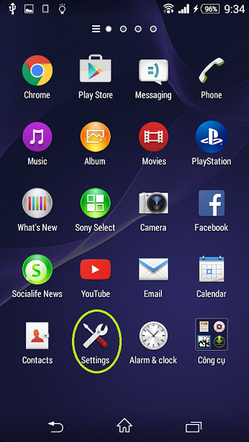

**Step2:** Go to Security

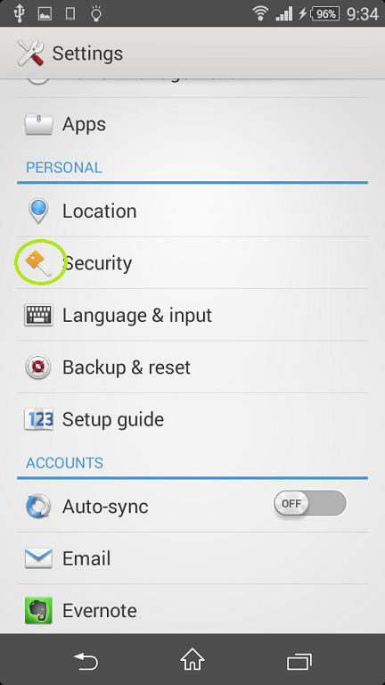

**Step 3:** Turn on Unknown sources

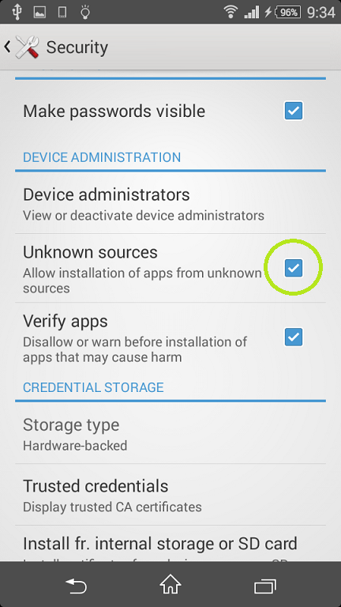

## Set up app

**Step 1**: Open file apk

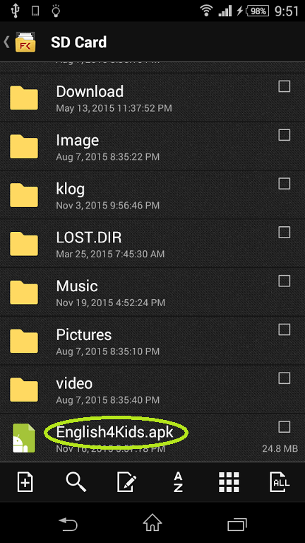

**Step 2:** Click install

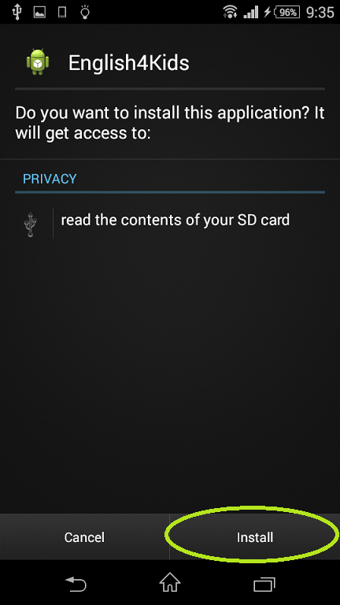

**Step 3**: Wait for install

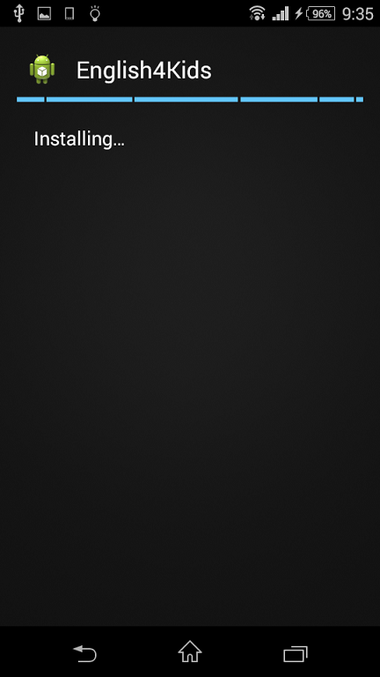

**Step 4**: App Installed

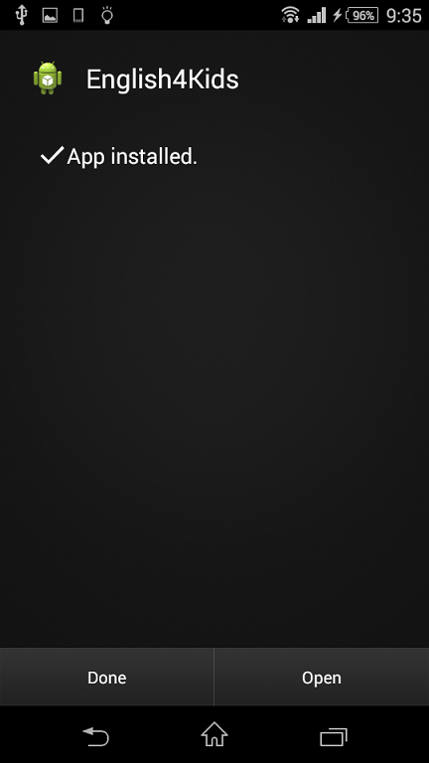

**Step 5**: Successful set up

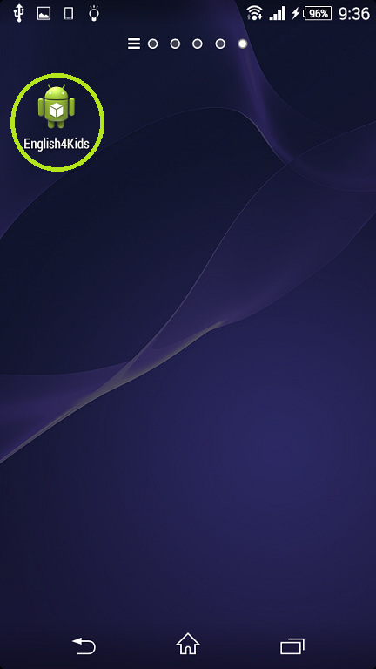

# VIII. User Guide

## 1. Introduction

This user guide has been developed to help users better understand to use this app by providing them simple step by step tutorials. So people can use it more easily.

## 2. Guidelines play game

### Play listening new words game

Step 1: Open app

Step 2: Tap on the “Listening Game”

Step 3: Tap on the “New words” game

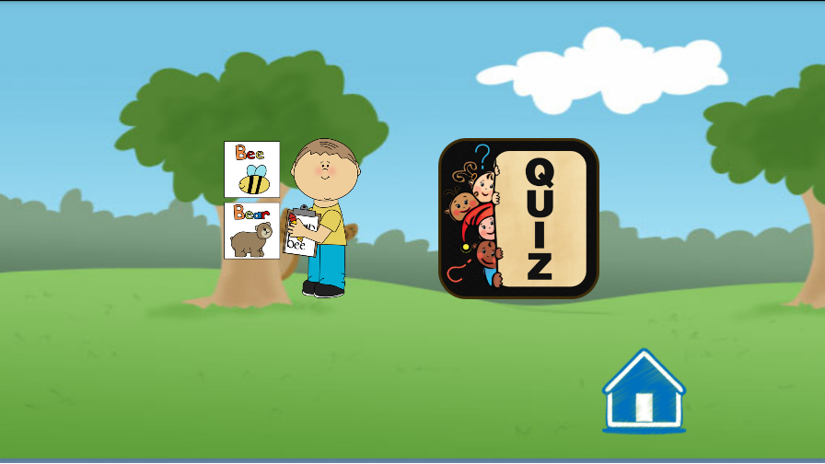

Step 4: Chose the section

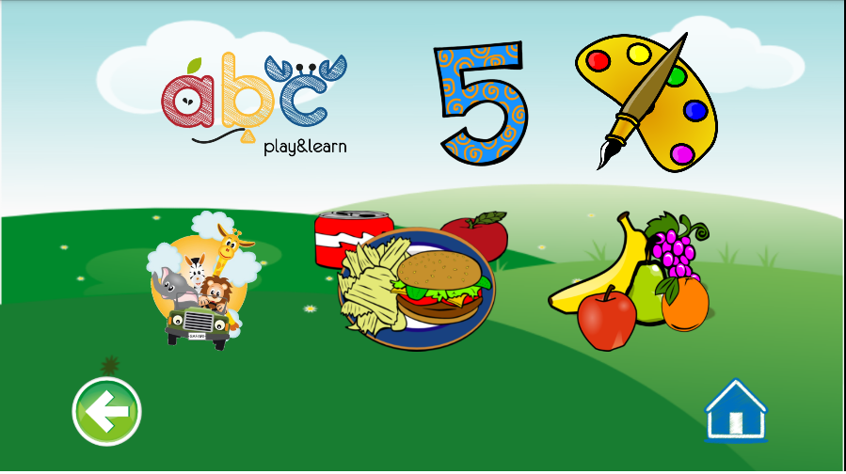

Step 5: Tap on the object, the sound will play and the text will show up

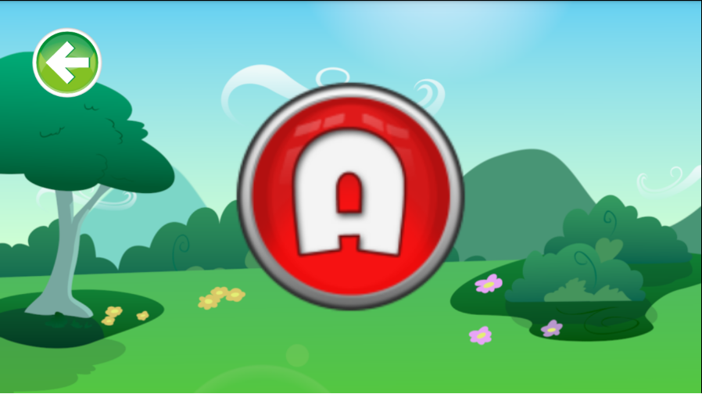

To show the next word, tap on the middle and move your finger to the left

To show the previous word, tap on the middle and move your finger to the right.

### Play listening multi choice game

Step 1: Open app

Step 2: Tap on the “Listening Game”

Step 3: Tap on the “Multi choice” game

If you want to back to the home page, click on the home icon.

Step 4: Choose the section



If you want to back to the home page, click on the home icon.

If you want to back to the menu of listening game, click on the back icon.

Step 5: Listen the question and choose the correct answer.

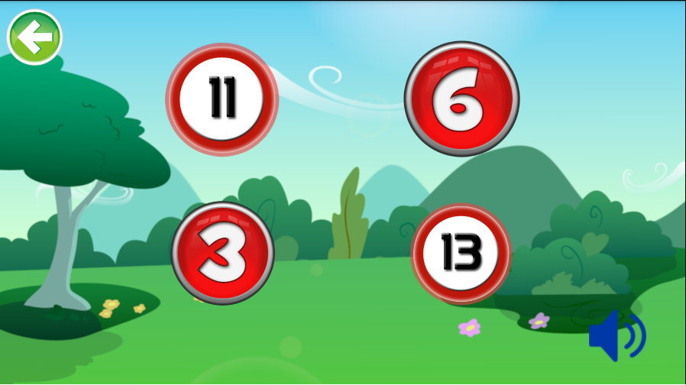

If you want to hear the question again, tap on the sound icon.

This game you must to choose the answer for each question, you can’t skip.

Step 6: Complete 10 question, see the result.

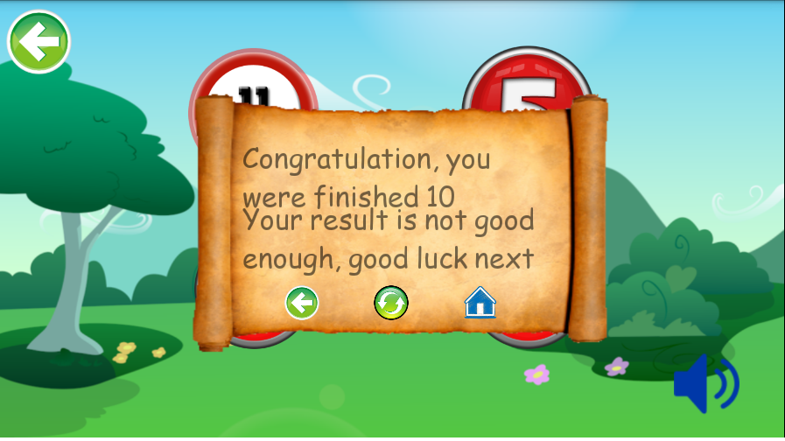

If you want to back to the home page, click on the home icon.

If you want to back to the choosing section, click on the back icon.

If you want to play again, click on the reset icon.

### Play speaking game

Step 1: Open app

Step 2: Tap on the “Speaking game” (this game require a network connection and device support google speech API)

Step 3: Tap on the object icon, the sound will play.

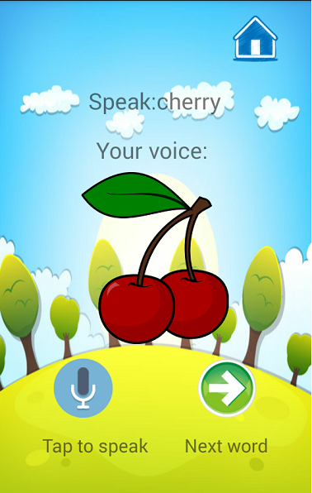

If you want to back to home page, tap on the home icon.

If you want to skip the question, tap on the next icon.

Step 4: Tap on the speak icon

If you want to cancel,

Step 5: Speak the word, saw the result

### Play writing queue game

Step 1: Open app

Step 2: Tap on the “Writing game”

Step 3: Tap on the “Queue” game – first game on the screen

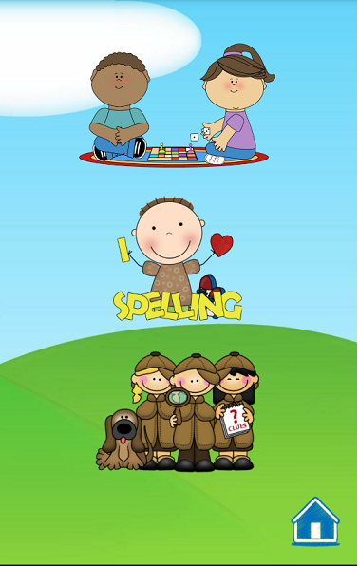

Step 4: Fill answer and tap submit button (the answer will be the word that start with the end alphabet of the question word)

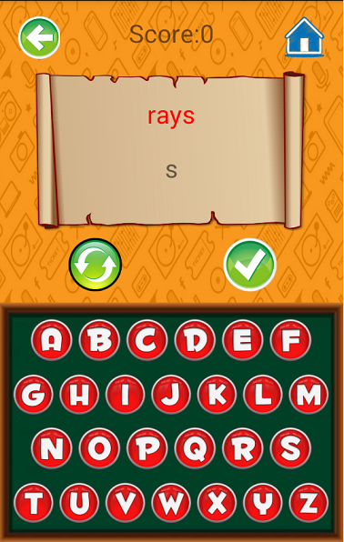

If you want to back to “Writing game”, tap on the back icon

If you want to go home, tap on the home icon

If you want to reset this question, tap on the reset icon

Step 5: Each right question, score will be plus one. Complete game went you are answer wrong, see the result.

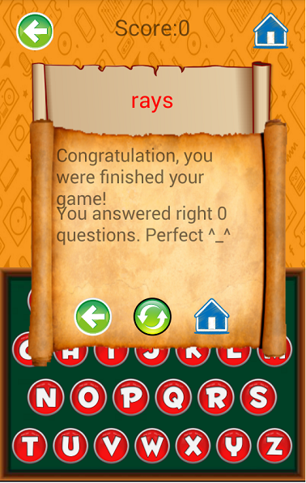

If you want to back to the home page, click on the home icon.

If you want to back to the choosing section, click on the back icon.

If you want to play again, click on the reset icon

### Play Writing missing word game

Step 1: Open app

Step 2: Tap on the “Writing game”

Step 3: Tap on the “Missing word game” section – second game on the screen

Step 4: Tap on the letter icon to complete the word

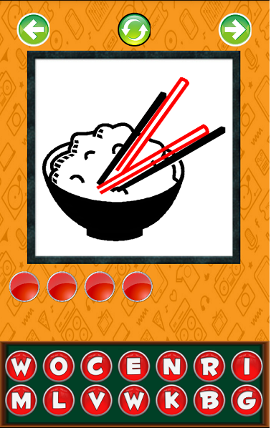

If you want to reset this question, tap on the reset icon

If you want to back to choosing game, tap on the back icon.

If you want to skip this question, tap on the next icon.

Step 5: Each right question, score will be plus one. Complete 10 question, see the result.

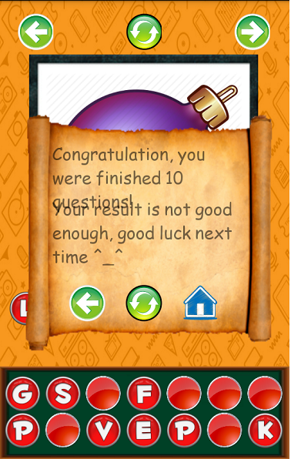

If you want to back to the home page, click on the home icon.

If you want to back to the choosing section, click on the back icon.

If you want to play again, click on the reset icon.

### Play Writing arrange word game

Step 1: Open app

Step 2: Tap on the “Writing game”

Step 3: Tap on the “Arrange word game” section – third game on the screen

Step 4: Tap on the letter icon to complete the word (all alphabet will be disorder, user will arranger it by themselves to find the missing alphabet)

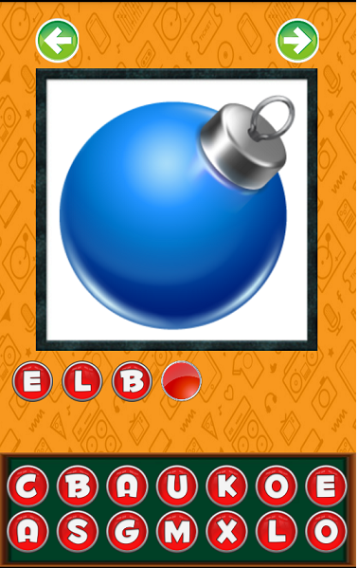

If you want to back to choosing game, tap on the reset icon

If you want to back to choosing section, tap on the back icon.

If you want to skip this question, tap on the next icon.

Step 5: Each right question, score will be plus one. Complete 10 question, see the result.



If you want to back to the home page, click on the home icon.

If you want to back to the choosing section, click on the back icon.

If you want to play again, click on the reset icon.

### Play vocabulary game

Step 1: Open app

Step 2: Tap on the “Vocabulary game”

Step 3: Choose the right answer for this image

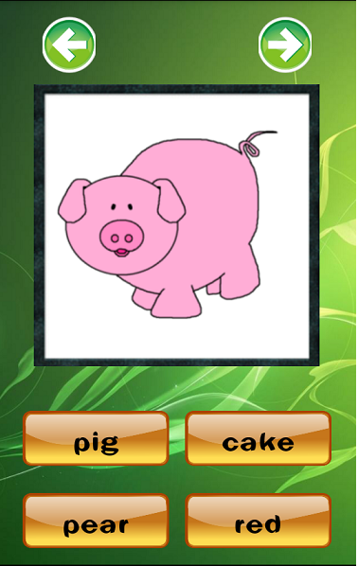

If you want to back to choosing game, tap on the back icon.

If you want to skip this question, tap on the next icon.

Step 4: Complete 10 question, see the result.

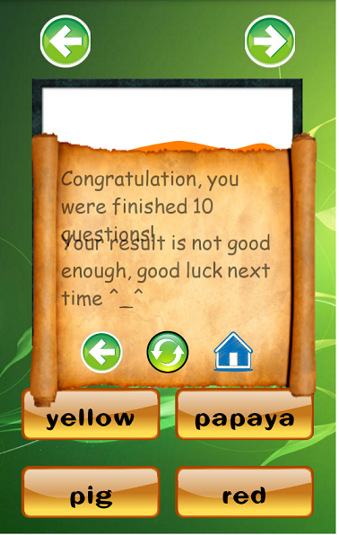

If you want to back to the home page, click on the home icon.

If you want to back to the choosing section, click on the back icon.

If you want to play again, click on the reset icon.

# IX Reference for project

-Information of exiting system

http://khoahoc.tv/nhung-phan-mem-hoc-tieng-anh-mien-phi-cho-be-tren-android-56342

-Topic of the game

http://www.tienganh123.com/tieng-anh-tre-em-theo-chu-de

-Source

<http://www.desktopwallpapers4.me/>

<http://www.1001freefonts.com/>

<http://megawallpapershd.com/>

<http://www.clipartsheep.com/>  
<https://www.youtube.com/>

<https://freesound.org/>

<http://stackoverflow.com/>

1. <http://www.idc.com/getdoc.jsp?pid=23571113&containerId=prVN23233011>
2. <http://www.vietnamandroid.com/tintuc/nguoi-dung-android-game.html>